Tech Connect Frontend
MTM Program Product
Software Requirements Specification
Version 0.4
March 23, 2021

Standard Version Number: 3.5
Standard Version Date: March 10, 2018
Version History
Version | Date | Authors | Comment
0.1 | 2/10/2021 | Class of ESOF 328, spring 2021 | Information from 1st client meeting
0.2 | 2/24/2021 | Class of ESOF 328, spring 2021 | Information from 2nd client meeting
0.3 | 3/8/2021 | Class of ESOF 328, spring 2021 | Information from 3rd client meeting
0.4 | 3/23/2021 | Class of ESOF 328, spring 2021 | Information from 4th client meeting

Montana Tech Software Engineering Students:
These Montana Tech Method software engineering standards encapsulate Dr. Ackerman’s decades of experience in the software industry, the IEEE software engineering standards, and many suggestions from various texts. They have gone through many revisions and additions over the last several years. They are part of your software engineering studies so that (1) you may have the experience of developing software to a standard (which you may find you need to do if you take a job that requires high reliability software), and so that (2) you will have the experience of developing high quality software. You are also invited to participate in the continuing evolution of these standards by studying them critically and making suggestions for their improvement and correction.

TABLE OF CONTENTS
1 Introduction 5
1.1 Software Purpose and Scope 5
1.2 Document Purpose and Contents 5
1.3 References 6
2 General Factors 6
2.1 Product Perspective 6
2.2 Product Features 6
2.3 Environmental Conditions 7
2.4 User Role Characteristics 8
2.5 Dependencies 8
2.6 Assumptions 8
3 Use Cases/User Stories 8
3.1 Roles 9
3.2 Use Cases 9
3.2.1 Create Profile 9
3.2.2 Update Profile 10
3.2.3 Send Message 12
3.2.4 Initialize consent information 13
3.2.5 Update consent information 14
3.2.6 Searching for other Users 15
3.3 User Stories 16
3.3.1 Montana Tech to User Connection 16
4 Specific Requirements 16
4.1 Functional Requirements 16
4.1.1 Login 16
4.1.2 Create Profile 16
4.1.3 Update Profile 16
4.1.4 Setting initial consents 17
4.1.5 Updating consents 17
4.1.6 Messaging other users 17
4.1.7 Search for other users 17
4.1.8 Search for Tech information 17
4.2 Quality Attributes 17
4.2.1 Availability 17
4.2.2 Human Factors 18
4.2.3 Usability 18
4.2.4 Performance 18
4.2.5 Security 18
4.2.6 Reliability 18
4.2.7 Maintainability 18
4.2.8 Enhanceability/Extendibility 18
4.2.9 Portability 18
4.2.10 V&V Activities 18
4.2.11 Adaptability 18
4.3 Non-Functional Requirements Which Are Not Quality Attributes 18
4.3.1 External Interface Requirements 18
4.3.2 Development Environment 19
4.3.3 Delivery Environment 19
4.3.4 Design Constraints 19
4.3.5 Database 19
4.3.6 Deliverable Items, Dates and Conditions 19
4.3.7 Cost 19
4.3.8 Standards 20
5 Future Enhancements 20
Appendices 21
Appendix A: Definitions, Acronyms, and Abbreviations 21
Definitions 21
Acronyms and Abbreviations 21
Appendix B: Analysis Models 22
Appendix D: Report Specification 23
Appendix E: Business Rules 24
Appendix F: Sample User Interface 24
Appendix G: Issues 24

FIGURES
Figure 1: Ecosystem Map 6
Figure 2: Context Diagram 7

Introduction
This section provides an overview of Tech Connect. It describes the business objectives and vision of Tech Connect, as well as the purpose and contents of this document.

Software Purpose and Scope
The business objectives of Tech Connect is to:
- Provide the ability to connect with the Tech family for professional or social purposes with graduates informally sharing information about potential jobs, internships, events, and start-up opportunities.​
- Enable Montana Tech to share information and provide a portal to other Montana Tech systems, such as Digger Recruiting.​
- Encourage and make it easy for alumni and graduating students to add data to the system and to keep it updated.

Its vision follows:

For Montana Tech alumni and graduating students who wish to maintain strong networking relationships with other users and Montana Tech itself, the Tech Connect frontend is a web application that allows users to distribute their information, view the information of others, and socialize. Unlike general social media platforms, our product will have the advantage of being the first system created specifically for Montana Tech that allows users the ability to connect after they graduate.

Document Purpose and Contents
The purpose of this Software Requirements Specification (SRS) document is to give readers an understanding of Montana Tech’s goals and needs for a Tech Connect frontend to the Graduate Information Tracking Webservice (GIT Webservice). This document is a guide to future developers on the desired features, functionality, and behaviors of the Tech Connect frontend. This document can also be used to design tests to ensure the module behaves as intended.

This SRS was developed by the students of the spring 2021 offering of Software and Requirements and Specification course, ESOF 328, at Montana Tech. It has been developed in part by alumni, faculty and administrative personal of Montana Tech. Thanks goes to Natasha Chadwell, Phil Curtiss, Justin Malsam, Kelvin McManus and Diane Warthen. The main audience of this document are the clients as well as the developers that will use this document to implement the system.

References
Michelotti, Jacob (2020). Graduate Information Tracking Webservice (GIT Webservice), Product Software Requirements Specification Document v1.0, Aug. 2, 2020. https://katie.mtech.edu/classes/esof328/Project/Graduate_Webservice_SRS.pdf

General Factors

This section provides a high-level view of the Tech Connect system, its major functions, environment, users, and dependencies.

Product Perspective
Tech Connect is a web application that will use the GIT Webservice to store and manipulate data. Tech Connect will be one, of possibly many frontends, of the GIT Webservice. Figure 1 show the ecosystem map for Tech Connect.

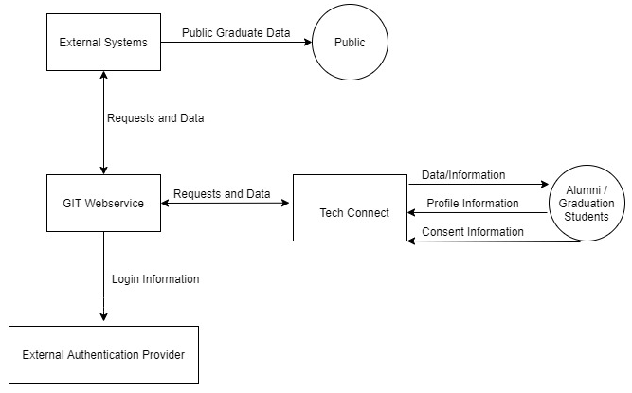
Figure 1: Ecosystem Map

Product Features
Tech Connect will have the following features:
- Profiles: Tech Connect will allow alumni and graduating students to create and personalize a profile to share their personal and professional information with other users.
- User to user connections: Tech Connect will provide a messaging system and a search system to facilitate connections between users within the system.
- Montana Tech to user connections: Tech Connect will enable users to view information about Montana Tech, and be directed to existing Tech information or services, allowing Montana Tech faculty to keep users up to date on Tech happenings.

Environmental Conditions
Tech Connect will work in conjunction with the GIT Webservice. As this webservice will interface with external authentication providers such as Montana Tech’s Central Authentication System, CAS, Tech Connect will also. Additionally, the GIT Webservice will have its own internal authentication, so Tech Connect will utilize that as well. Figure 2 depicts the environment of Tech Connect.

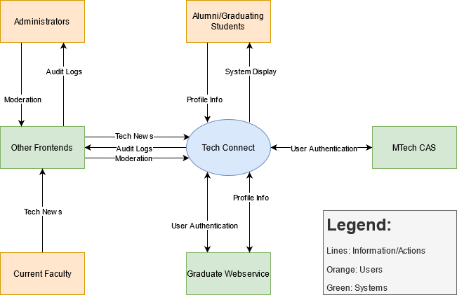
Figure 2: Context Diagram

User Role Characteristics
Following are the primary user roles of Tech Connect.
- Alumni
- Graduating Students

Users in the role of Graduating Students and Alumni will interact with Tech Connect in the same way. The only difference is that users with an active CAS account, will utilize that for authentication, while others may use another method.

Users in the role of Alumni must have a diploma from Montana Tech. Graduating Students are users who expect to be graduating from Tech within the next year. That is, students who expect to graduate in May or the summer of a given year may create accounts in Tech Connect any time after the beginning of the fall term of the previous year. Students who expect to graduate in December of a given year may create accounts in Tech Connect any time after the beginning of the spring term of the previous year. Other Montana Tech students may not create accounts in Tech Connect, but may be able to interact via a different frontend in a similar way that the General Public may interact.

The primary users of Tech Connect are graduating students and alumni. These users should have a basic understanding of profiles, messaging systems, and interacting with web information in general.

Dependencies
This system depends on the Graduate Information Tracking Webservice, which itself depends on Montana Tech’s Central Authentication System and possibly another authentication system.

Assumptions
Tech Connect is dependent only on the Graduate Information Tracking Webservice. Although it can include connections to other Montana Tech systems, these are not necessary to Tech Connect’s functionality.

Use Cases/User Stories
Use cases and user stories describe how users will interact with Tech Connect. In this section the roles in which users will interact with Tech Connect are listed, along with use cases and user stories that users playing that role, may perform.

Use cases outline, from a user’s point of view, Tech Connect’s behavior as it responds to user interactions. User stories provide less detail than use cases. This section begins by listing what user cases and user stories each role can perform. Linked use cases and user stories are detailed in this section. Non-linked use cases and user stories are suggested but not described.

Roles
The following table contains roles in which users can interact with Tech Connect, along with the use cases and user stories, they can perform.

Role | Use Cases / User Stories
Alumni / Graduating Students | - Create profile  - Update profile  - Initialize consent information  - Update consent information  - Messaging within the system.  - Modify message notification status

Use Cases
The following use cases outline, from a user’s point of view, Tech Connect’s behavior as it responds to user interactions. Each use case is represented as a sequence of steps, beginning with a user’s goal, and ending when that goal is fulfilled, or the user has exited the use case.

Create Profile
Created By: | Burak Adam | Last Updated By: | Class
Date Created: | 3/2/2021 | Date Last Updated: | 3/23/2021
Actors: | Alumni, Graduating Students
Description: | Create a profile and fill profile information form.
Preconditions: | - User is authenticated  - User doesn’t have a profile
Postconditions: | - User profile is created.
Normal Flow: | 1.0 Create Profile  - User indicates desire to create profile.  - A profile information interface appears that allows actions such as:  - Fill in mandatory personal information  - Select/upload profile picture.  - Fill in job related information  - Approve/reject public and analytic consent for items  - User makes changes to form and submits  - Profile is saved and use is informed that the profile is saved.
Alternative Flows: | 1.1 User does not submit, and no changes were made (branch during step 2)  - User navigates away from the interface or indicates a desire to exit the interface before any changes were made.  - Use case exits.  1.2 User does not submit after changes were made (branch during step 2)  - User navigates away from the interface or indicates a desire to exit after changes have been made.  - User is warned that they have unsaved changes and asked if they wish to proceed.  - User indicates preference.  - If ‘yes’ use case exits; if ‘no’ the user remains in the interface (i.e. they return to step 2).
Exceptions: | 1.0.E.1 Internal error (branch after step 2)  - The system is not able to connect to the database or some other internal error.  - User is informed that an error occurred and that no changes were made to the system.
Includes/Extends: | None
Priority: | High (User to user connection cannot be achieved without a profile)
Frequency of Use: | One time for each user. A user can create only one profile.
Business Rules: | None
Special Requirements: | None
Assumptions:
Notes and Issues: | Several fields in the GIT Webservice ( name at the time of graduation, graduation year, honors, major, department graduated from, country and state of home address when graduating, are read-only. It has not yet been determined how these fields will be populated.

Update Profile
Created By: | Burak Adam | Last Updated By: | Class
Date Created: | 3/2/2021 | Date Last Updated: | 3/23/2021
Actors: | Alumni, Graduating Students
Description: | User wants to update information on his/her profile.
Preconditions: | - User is authenticated  - User has a profile
Postconditions: | - User profile is updated
Normal Flow: | 2.0 Update Profile  - 1. User indicates desire to create profile.  - A profile information interface appears to allow user to make changes.  - User makes changes to form and submits  - Profile is saved and use is informed that the profile is saved.
Alternative Flows: | 1.1 User does not submit, and no changes were made (branch during step 2)  - User navigates away from the interface or indicates a desire to exit the interface before any changes were made.  - Use case exits.  1.2 User does not submit after changes were made (branch during step 2)  - User navigates away from the interface or indicates a desire to exit after changes have been made.  - User is warned that they have unsaved changes and asked if they wish to proceed.  - User indicates preference.  - If ‘yes’ use case exits; if ‘no’ the user remains in the interface (i.e. they return to step 2).
Exceptions: | 1.0.E.1 Internal error (branch after step 2)  1. The system is not able to connect to the database or some other internal error.  2.User is informed that an error occurred and that no changes were made to the system
Includes/Extends: | None
Priority: | High (User to user connection cannot be achieved without a profile)
Frequency of Use: | One time for each user. A user can create only one profile.
Business Rules: | None
Special Requirements: | None
Assumptions: | None
Notes and Issues: | Another GIT Webservice frontend will enable administrators to generate change logs so periodically the administrator can check changes to profile data to make sure the changes are reasonable.

Send Message

Created By: | Burak Adam | Last Updated By: | Class
Date Created: | 3/2/2021 | Date Last Updated: | 3/23/2021
Actors: | Alumni, Graduating Students
Description: | User wants to communicate with other users by sending message
Preconditions: | - User is logged in to Tech connect and has permission to perform this action.  - User has a profile.
Postconditions: | - Messages send to target users.  - An email sends to target users mail addresses indicating they received message on Tech connect
Normal Flow: | - Send Message  - User indicates desire to send message to a user or group of users.  - A messaging interface appears to allow user enter text body and username.  - User submits entered text to target user/users.  - A confirmation message indicating the success of submission appears.  - Message saved to database.
Alternative Flows: | - User does not submit, and message does not send (branch during step 2)  - User navigates away from the interface or indicates desire to exit the application before submitting the message.  - Use case exits.
Exceptions: | 1.0.E.1 Internal error (branch after step 2)  - The system is not able to connect to the database or some other internal error.  - User is informed that an error occurred and that no changes were made to the system.  1.0.E.2 User not found error (branch after step 2)  1. The system cannot find the user in the database.  2. User is informed that user does not exist in the database and message cannot be send.
Includes/Extends: | None
Priority: | Medium
Frequency of Use: | Multiple times for each user depending on how often users wants to send message.
Business Rules: | None
Special Requirements: | None
Assumptions: | - User profile created by user and the message target has a user profile.  - User opted in for e-mail notification.
Notes and Issues: | None

Initialize consent information
Created By: | Andrew Moreno | Last Updated By: | Class
Date Created: | March 2, 2021 | Date Last Updated: | March 23, 2021
Roles: | Alumni, Graduating Students
Description: | Initialize consent information
Preconditions: | - User is authenticated  - User is in the process of creating a profile
Postconditions: | User may have initialized their consent information for both analytic and public use
Normal Flow: | 1.0 Initialize Consent Information  - User reaches the “Consent Information” step in creating a profile.  - System displays a form allowing users to consent to individual or groups of information for analytic and/or public use.  - User fills out the form.  - User submits the form.  - System saves the consent information in the Graduate Web Service.  - System displays confirmation to user that form was submitted.
Alternative Flows: | 1.1 Abort Profile Creation (branch before step 4)  - User indicates that they would like to about profile creation.  - System aborts profile creation.  1.2 Unfilled Information (branch after step 4)  1. User attempts to submit a form with required fields not completed  2. System displays error message asking user to complete the form  3. Return to step 2.
Exceptions: | None
Includes/Extends: | Extends “Create Profile”
Priority: | Critical
Frequency of Use: | Once on account creation
Business Rules: | None
Special Requirements: | None
Assumptions: | None
Notes and Issues: | None

Update consent information
Created By: | Andrew Moreno | Last Updated By: | Class
Date Created: | March 2, 2021 | Date Last Updated: | March 23, 2021
Roles: | Alumni, Graduating Students
Description: | Update consent information
Preconditions: | - User is authenticated.  - User has created a profile in which consent was initialized.  - User’s consent information may or may not be expired.
Postconditions: | - User may have updated their consent information
Normal Flow: | 1.0 Update Consent Information (Existing Consent Information)  - User navigates to where they can update their consent information in their profile.  - System displays a form allowing users to update their consent to individual or groups of information for analytic and/or public use.  - User completes and submits the form.  - System saves the consent information in the Graduate Web Service, and displays a message that the form was submitted.
Alternative Flows: | 1.0 User is responding to system notification (branch before step 1)  - System notifies user that their consent information is going to/has expired.  - User clicks link in system notification or navigates to where they can update their consent information in their profile.  - Return to step 2.  1.1 Abort Profile Creation (branch before step 4)  - User indicates that they would like to about profile creation.  - System aborts consent update.  1.2 Unfilled Information (branch after step 4)  1. User attempts to submit a form with required fields not completed  2. System displays error message asking user to complete the form  3. Return to step 3.  1.3 Unfilled Information (branch during step 5 in 2.0 normal flow)  - User attempts to submit a form with fields not completed.  - System queries user to ask if they would like to update the unfilled fields.  User confirms partial update or returns to step 3.
Exceptions: | None
Includes/Extends: | Extends “Update Profile”
Priority: | Critical
Frequency of Use: | When consent information expires or when users want to change their existing consent information.
Business Rules: | None
Special Requirements: | None
Assumptions: | None
Notes and Issues: | None

Searching for other Users
Created By: | John Nelson | Last Updated By: | Class
Date Created: | March 17, 2021 | Date Last Updated: | March 23, 2021
Roles: | Alumni, Graduating Students
Description: | Searching for other Users
Preconditions: | User is authenticated.
Postconditions: | Search results are displayed
Normal Flow: | 1.0 Searching for other Users  1. User enters search term or terms into search box.  Such as graduation year, state, name, company and major  2. System displays the search results, including a profile picture if a picture is available
Alternative Flows: | 1.0 User filters the search results (branch after step 2)  1. User selects a filter or filter to apply to search results  Such as date range, area of country, by major and field of work  2. Go to step 2  Alternative Flow maybe repeated until user is done.
Exceptions: | None
Includes/Extends: | Create Profile and Update Profile
Priority: | High
Frequency of Use: | Whenever a user decides they want to search for other Users
Business Rules: | None
Special Requirements: | None
Assumptions: | None
Notes and Issues: | None

User Stories
User stories provide less detail than use cases, as it is expected that one or more clients will be available during the development of Tech Connect, to provide guidance on how the user story should unfold.

Montana Tech to User Connection

Tech News: As an Alumnus or Graduating Student, I would like to view Montana Tech news to be catch up on Tech happenings.

Specific Requirements
This section is to contain all of the requirements for Tech Connect. Currently, however, it only shows a few example requirements. These could be alphabetized by name. Instead, they are presented in the order they are likely to occur.

Functional Requirements

Login
Tech Connect shall provide an interface for users be authenticated by the GIT Webservice. For graduating students this will be via CAS (Montana Tech’s Central Authentication Service). For alumni another authentication service may be used.
Rationale: Graduating students will have an CAS account, while alumni, may not.
Priority: Critical

Create Profile
The system shall facilitate creating a new profile by a user who doesn’t already have a profile. After creation, the user will have a profile on Tech Connect and the user will be able to access the other features of Tech Connect.
Rationale: A new user will need a way to be added to the system.
Priority: Critical

Update Profile
The system shall facilitate updating a profile by a user who already has a profile. After the profile is updated, the user will have their new data in the system for their profile and the new information will be able to be used for analytics and searchable by other users
Rationale: A user should be able to update their information in the system to keep it current.
Priority: Critical

Setting initial consents
The system shall allow a user to set initial consents for data in their profile. After the consents are initialized, the data can be used in other parts of the system based on the consent choice. ​
Rationale: A user should be able to decide how their data will be used. ​
Priority: Critical ​

Updating consents
The system shall allow a user to update their consents. After the consents are updated, how the data is used will be based on the updated consents.
Rationale: A user should be able to change how their data will be used. ​
Priority: Critical ​

Messaging other users
The system shall enable a user to message another user, or a group of users.
Rationale: Messaging is an important part of purpose behind Tech Connect ​
Priority: Medium

Search for other users
The system shall enable a user to search for other profiles. More specifics are known about what will be searched for, and that should be included here.
Rationale: Users must be found before messages can be sent to them.
Priority: Medium

Search for Tech information
The system shall enable a user to search for other profiles.
Rationale: Users must be found before messages can be sent to them.
Priority: Medium

Quality Attributes
[This subsection specifies criteria used to judge the operation of a system, rather than specific behaviors of the system. Specify the specific behavior of the system in the functional requirements.]

Availability

Human Factors
[Not everyone has the same inherent mental and physical capabilities vis-à-vis a given computer application. For example if sound is part of the application, will other clues be given that will enable a hard of hearing user to use the proposed application as well as person with normal hearing; similarly for color blindness. Define these factors, if necessary, with validation criteria.]

Usability

Performance

Security

Reliability
[Reliability is specified as mean-time-to failure of an operational item. An operational profile must be specified.]

Maintainability

Enhanceability/Extendibility
[If the future it might be necessary to change the Functional requirements in specified ways, what is the maximum estimated effort required to make such changes and what is the rationale for this estimate?]

Portability
[If in the future it might be necessary to change the above Development or Delivery Environments (DV or DL) to other specified environments, what is the maximum estimated effort required to implement such changes and what is the rationale for this estimate]

V&V Activities

Adaptability
[If it is specified that in the future it might be necessary to change any of the above Non-Functional requirements, what is the maximum estimated effort required to implement such changes and what is the rationale for this estimate.]

Non-Functional Requirements Which Are Not Quality Attributes
[This subsection specifies non-functional criteria such as platform, deployment, interface, design and document requirements. If there is not a document describing project requirements, those requirements (cost, schedule, etc.) can be placed here.]

External Interface Requirements

Hardware

Software

Communications

Development Environment

Delivery Environment

Site
[This subsection should specify any requirements for installation or operation of the software that might change the pre-existing configuration of the user site.]

Operations
[This subsection should specify normal and special operations required by the user to include:
- Various modes of operation within the user organization
- Periods of interactive operations and unattended operations
- Data processing support functions
- Backup and recovery operation.]

Design Constraints
[Sometimes a client will require certain design constraints, for example the use of a certain system configuration or the use of particular algorithm. Such constraints are described in this subsection.]

Database
[This optional subsection specifies requirements for any database to be developed as part of the product. The information in this section may include:
- Types of information to be stored
- Table attributes (queried, supporting, updated)
- Frequency of access
- Accessing capabilities and requirements
- Data elements and file descriptors
- Retention requirements for data.]

Take care to avoid design details. Unless so requested by the client, this section should only contain as much information about saved data as is necessary to fully document any of the requirements given above.]

Deliverable Items, Dates and Conditions

Cost

Standards

Future Enhancements
It is expected that other frontends will be created for the GIT Webservice. For example, a separate frontend can use information stored in the GIT Webservice to generate analytic data for Faculty and Graduates, another frontend can facilitate administration of the GIT Webservice; a third for faculty members to add forums and blogs for alumni to see.

Including support for forums and blogs was discussed. The difficulty of keeping forums and blogs was noted.

Including support for reviewing or auditing data added by user to ensure all of the information in the system is appropriate in an administration frontend was mentioned.

It was decided to not include these in this first version of Tech Connect. They may be included in later frontends.

It was noted that avoiding dependencies of Tech Connect to other systems could be problematic if those other systems are removed.

Appendices
[In some cases, it is helpful to move items out of the main portion of the Software Requirements and Specification Document. These items can appear here. Alternatively, move these items into the main part of the document.]

Appendix A: Definitions, Acronyms, and Abbreviations
[This appendix should provide the definitions of all terms, acronyms, and abbreviations required to fully understand your SRS.]

Definitions
Graduating Student | Any currently enrolled student who is expected to graduate within the next 2 semesters.
Current Faculty | Any faculty level employees of Montana Tech.
Alumni | Any formerly enrolled student who has graduated with a degree from Montana Tech.
Administrator | A Tech Connect user who acts in an administrative capacity.

Acronyms and Abbreviations
DB | Database
HW | Hardware
GIT Webservice | Graduate Information Tracking System Webservice
SDD | Software Design Description
SRS | Software Requirements Specification
SW | Software

Appendix B: Analysis Models
The activity diagram shows the process of updating consents.

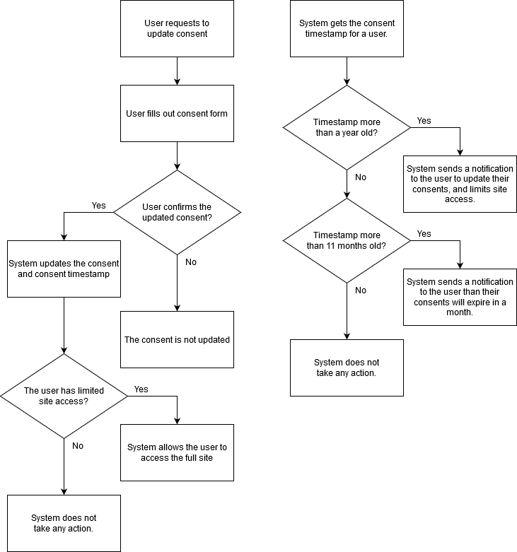

Figure3: Activity Diagram showing Consent Checking and Updating

Appendix C: Data Dictionary
[The data dictionary defines the composition of data structures and the meaning, data type, length, format, and allowed values for the data elements that make up those structures. In many cases, storing the data dictionary as a separate artifact, rather than embedding it in an SRS is beneficial. This also increases its reusability potential in other projects.

List data items alphabetically. Make each name a bookmark so each time the name occurs in this SRS it can be link to this entry via a hyperlink. Choose names with care. The expectation is that these names will persist in the design and implementation.]

Data Element | Description | Composition or Data type | Length | Values
Name of data item being defined | Textual description of the business meaning of the data element | For primitive data elements: data type (integer, floating point, alphabetic, date, etc.) and, as appropriate, format (e.g. date as MM/DD/YYYY).  For data structures show the components that comprise the structure. , | Maximum number of characters for primitives; blank for structures | List of allowed values, default, rules governing legal values, and any other description of the data values
… | … | .. | … | …

Appendix D: Report Specification
[This optional appendix contains descriptions of reports that the system needs to generate. Many applications involve generating reports from one or more databases, files or other information sources. Exploring the content and format of the reports needed is an important aspect of requirements develop. Describe the contents and layouts of each report, including changes being made in an existing version of the report. Indicate the conditions that will trigger generating the report (e.g., manual or automatic) the timing of report generation, and the disposition of the report, such as to whom it is sent or where it is stored.

Use the following template to document business rules.

Report ID:
Report Title:
Report Purpose:
Data Sources:
Frequency and Disposition:
Latency:
Visual Layout:
Header and Footer:
Report Body:
End-of-Report Indicator:
Interactivity:
Security Access Restrictions:

If appropriate, provide a mock-up or a sample of the report, or an illustration of a similar existing report, showing the desired layout. ]

Appendix E: Business Rules
[This optional appendix describes business rules that are relevant to the proposed system. Use the following template to document business rules.
ID | Rule Definition | Type of Rule | Static or Dynamic | Source
BR-1 | Definition 1 | Fact, constraint, computation | Static or dynamic | Name, role or document
… | … | .. | … | …
]

Appendix F: Sample User Interface
[If a sample user interface exists, place it here. Make it clear that this user interface is only an example. If something is required in the user interface, state that earlier in this document.]

Appendix G: Issues
[This optional appendix is a dynamic list of the open requirements issues that remain to be resolved, including TBDs, pending.]

