Conflict of Interest Software Requirements Specification

Version 0.4
4/10/2022

Template Version 3.5

Standard Version Number: 3.5
Standard Version Date: March 10, 2018
Version History
Version | Date | Authors | Comment
0.1 | 2/18/2022 | Students of Req & Spec, Spring 2022 - Nathan Blakenship, Matthew Gallagher, Tucker Kane, Brandon Mitchell | Introduction: business objectives, vision, context, environment
0.2 | 3/4/2022 | Same as above | General factors: functions/features, users
0.3 | 3/23/2022 | Same as above | Incorporate Etrieve into handling conflicts, added use cases and other details
0.4 | 4/10/2022 | Same as above | Back and forth of management plans, form and conflict management plan statuses, dashboard informatin

Template Version History
Version | Date | Authors | Comment
3.0 | 7/21/2012 | Frank Ackerman | Initiating standards versions
3.1 | 8/2/2012 | Frank Ackerman | Some non-functional requirements definitions. Added Adaptability, Enhanceability, and Portability
3.2 | 1/17/2013 | Frank Ackerman | Added usability comment
3.3 | 3/6/2013 | Frank Ackerman | Added a bit more explanatory text and final section 8.
3.5 | 3/10/2018 | Celia Schahczenski | Changed format of dates, rearranged, renamed items, removed Illustrative Use Cases, increased some explanations, added appendices including data and report sections.

Montana Tech Software Engineering Students:
These Montana Tech Method software engineering standards encapsulate Dr. Ackerman’s decades of experience in the software industry, the IEEE software engineering standards, and many suggestions from various texts. They have gone through many revisions and additions over the last several years. They are part of your software engineering studies so that (1) you may have the experience of developing software to a standard (which you may find you need to do if you take a job that requires high reliability software), and so that (2) you will have the experience of developing high quality software. You are also invited to participate in the continuing evolution of these standards by studying them critically and making suggestions for their improvement and correction.

TABLE OF CONTENTS
1 Introduction 6
1.1 Software Purpose and Scope 6
1.2 Purpose and Contents 6
1.3 Definitions, Acronyms, Abbreviations and References 7
1.3.1 Definitions 7
1.3.2 Acronyms and Abbreviations 8
1.3.3 References 8
2 General Factors 9
2.1 Product Perspective 9
2.2 Environmental Conditions 10
2.3 User Characteristic 13
2.4 Dependencies 13
2.5 Assumptions 14
3 Use Cases 14
3.1 COI Etrieve Actor 14
3.2 COI Etrieve Use Cases 15
1.1.1 Create/Edit Form 15
3.2.1 Aid in Management Plans 16
1.1.2 Create/Edit Manage Management Plans 17
3.2.2 Approve Management Plans 18
3.3 COI System Actor 19
3.4 COI System Use Cases 19
3.4.1 Dashboard Use Case 19
3.4.2 Generate Report 20
4 Specific Requirements 21
4.1 Functional Requirements 21
4.2 Quality Attributes 22
4.2.1 Availability 22
4.2.2 Human Factors 22
4.2.3 Usability 22
4.2.4 Performance 22
4.2.5 Security 22
4.2.6 Reliability 22
4.2.7 Maintainability 22
4.2.8 Enhanceability/Extendibility 22
4.2.9 Portability 22
4.2.10 V&V Activities 23
4.2.11 Adaptability 23
4.3 Non-Functional Requirements Which Are Not Quality Attributes 23
4.3.1 External Interface Requirements 23
4.3.2 Development Environment 23
4.3.3 Delivery Environment 23
4.3.4 Design Constraints 23
4.3.5 Database 24
4.3.6 Deliverable Items, Dates and Conditions 24
4.3.7 Cost 24
4.3.8 Standards 24
5 Future Enhancements 24
Appendices 25
Appendix A: Analysis Models 25
Appendix B: Data Dictionary 26
Appendix C: Report Specification 26
Appendix D: Business Rules 28
Appendix E: Sample User Interface 29
Appendix F: Issues 29

Table of Figures
Figure 2.1 COI System Ecosystem Map 11
Figure 2.2 COI Etrieve Context Diagram 12
Figure 2.3 COI System Context Diagram 12
Figure 0.1 Form and Management Plan State Transition Diagram 25

Table of Tables

Table 1.1 Definitions 8
Table 1.2 Acronyms 8
Table 2.1 COI Etreive User Classes 13
Table 2.2 COI System User Classes 13
Table 0.1Business Rules 28

Introduction
This section provides an overview of the Conflict of Interest (COI) System and COI
Etrieve, the purpose of this document, and definitions, acronyms and references related to conflicts of interest.

Software Purpose and Scope
The purpose of the Conflict of Interest System (COI) System and COI Etrieve is to help the
Research Office handle conflicts of interest for Montana Technological University
(subsequently known as Montana Tech). For Montana Tech affiliated members who fall
under the COI policy, the COI System consists of an interactive user interface to view statistics, generate reports, and store COI data, while COI Etrieve is a third-party application for collection that data. These systems together will reduce user and staff input to less than 40 hours per year, guarantee a 95% or better completion rate for all faculty and staff, and generate annual reports. Unlike the previous systems used by the Research Office, this combined system accurately collects statistics, chooses correct recipients, saves time, educates users on the COI policy, and generates reports.

Purpose and Contents
The purpose of this Software Requirements Specification (SRS) is to give readers an
understanding of Montana Tech’s goals and needs for a COI System and COI Etrive. It
provides a guide for future developers on the desired features, functionality and behaviors of
the these systems. This document can be used to design tests to ensure an
implementation behaves as intended.

Customers sometimes find sample interfaces easier to understand than documents such as this SRS. Sample user interfaces demonstrate one way that the software could appear. This document goes further to tell precisely what functionality is needed.

This document does not attempt to tell how this software should be implemented except in those cases where the customers want the application to be developed in a particular way. Deciding exactly what a system should do, before deciding how it will do it, reduces development time considerably.

This SRS was developed by students in Software Requirement and Specification (ESOF 328), in the Spring 2022 at Montana Tech. It has been developed in part by faculty members, administrative personal and students. Thanks goes to Angela Lueking, Jill Yoder, Muhammad Abdul Basit UR Rahim, Trevor Osborne, and Ryan Hessler. The main audience of this document are the clients as well as the developers that will use this document to implement the system.

Definitions, Acronyms, Abbreviations and References
This section defines technical terms used in this document, as well as the expansions of acronyms and abbreviations, and important references.

Definitions
This subsection contains definitions of terms used in this document.

Bins | Each completed COI form will be put into one of the following “bins” for filtering by the Admins:  - No Conflict  - Minor Conflict  - Major Conflict
Conflict of interest and financial disclosure | Occurs “…when there is a potential divergence between the employee’s private interests and professional obligations to Montana Tech, such that an independent observer might reasonably question whether the employee’s professional actions or decisions could be influenced by considerations of personal gain (financial or otherwise).” From the Conflict of Interest and Financial Disclosure policy
Grant Active Department | Departments whose faculty members are likely to write grants and thereby need to be concerned about conflicts of interests. Example grant active departments are Chemistry, Biology, Physics and Engineering.
Person of Interest | Anyone who is required to complete a COI form.
Status of COI form | COI forms can have one of the following distinct statuses:  - Not Started: The Person of Interest has not started or  modified their COI form.  - In Progress: The Person of Interest has made changes to  their COI form but hasn’t submitted it yet.  - Submitted: The Person of Interest has signed and  submitted their COI form for review by personnel in the Research Office.  - Rejected: The COI form has inconsistencies or is missing  important information and needs to be fixed.  - Complete: The COI form has been reviewed and signed by the appropriate parties.
Status of management plan | Management plans can have one of the following distinct statuses:  - N/A: The Person of Interest has not submitted their COI form yet, so the management plan’s state is currently not applicable.  - No Plan Needed: No conflicts exist, so no conflict management plan is needed.  - In Review: The management plan is waiting to be reviewed by Research Office personnel.  - Plan Required: A management plan needs to be created manually by Research Office personnel due to one or more significant, unique or complicated conflicts.  - Pending: A management plan is available to the Person of Interest and is awaiting their signature.  - Submitted: The Person of Interest has signed their management plan and has submitted it.  - Complete: The management plan has been signed by both the Person of Interest and the appropriate authority associated with the Research Office.
Table 1.1 Definitions

Acronyms and Abbreviations
Acronyms and abbreviations found in this document are included in this subsection.

COI | Conflict of Interest
FTE | Full-Time Equivalent, a designation of workload for faculty members or students. 1.0 FTE is equivalent to 40 hours. Students are considered to be  full-time at 0.5 FTE or higher.
PoI | Person of Interest, anyone who will be using the COI System to sign a conflict of interest form
SRS | Software Requirements Specification, term used for this document
SSO | Single Sign-On, the secure login system commonly used for Montana Tech applications
Table 1.2 Acronyms

References
References relevant to the Conflict of Interest System are given in this subsection.

Banner
https://www.ellucian.com/solutions/ellucian-banner-human-resources

Conflict of Interest and Financial Disclosure Policy (1998), Montana Technological University,
https://www.mtech.edu/research/files/conflict-interest-financial-disclosure.pdf

Conflict of Interest Disclosure Statement and Certification Portal, Montana Technological University, https://mtlbsso.mtech.edu/idp/profile/cas/login?execution=e1s1

Etrieve
https://www.softdocs.com/etrieve

Montana Technological University Faculty/Staff Handbook
https://www.mtech.edu/facultystaff/fac-staff-handbook-acc.pdf

General Factors
A high-level overview of what COI Etrieve and the COI System will do, their running environments, who will use them, their dependencies, along with assumptions made about them are included in this section.

Product Perspective
This system is meant to serve as a replacement to the current COI process. In addition, this project will be dependent on the Etrieve, Banner and Single Sign-On systems of Montana Tech.

Product Functions to handle Conflicts of Interests.

COI Etreive will enable users to:
- Educate: COI Etrieve will educate users on what is a conflict of interest, the importance of disclosing potential conflicts, and the consequences of not properly disclosing information on the form.
- Create: COI Etrieve will enable People of Interest to complete, sign, and submit COI forms online, approving the document with their digital signature.
- Create management plans: COI Etrieve will generate templated management in situations where a conflict is minor, common, or simple. COI Etrieve will facilitate the creation of management plans by Research Office personnel.
- Sign forms: COI Etrieve will allow certain individuals to sign off on COI forms and management plans.

The COI System will:
- Manage forms: The COI System will allow Research Office personnel to easily see the status of all COI forms.
- Aid in conflict management: The COI system will allow Research Office personnel to easily see who has potential conflicts, the status of those conflicts, and to record how those conflicts will be managed.
- Filter: Filter COI forms by their status and other relevant information.
- Report: The COI system will generate yearly reports on the data gathered from the signed COI forms to submit to Montana Tech’s Board of Regents. Status reports can also be made at any time.
- Store: The COI system will store conflict of interest information for three years or until the conclusion of research.

Environmental Conditions
The Montana Board of Regents requires the submission of annual conflict of interest reports from each of its universities, including Montana Tech. Banner holds the information necessary to uniquely identify employees and graduate students engaged in research. Etrieve will be used to create and complete COI and management plan forms. Microsoft Outlook is the most likely tool to be used to distribute links to Etrieve as each employee and student has their own unique email address. COI System authorization will be Montana Tech’s Single Sign-On (SSO) System. Figure 2.1 COI System Ecosystem Map shows the interactions of the COI System.

Context diagrams show the context in which a system will operate. Two context diagrams are shown below: Figure 2.2 COI Etrieve Context Diagram and Figure 2.3 COI System Context Diagram.

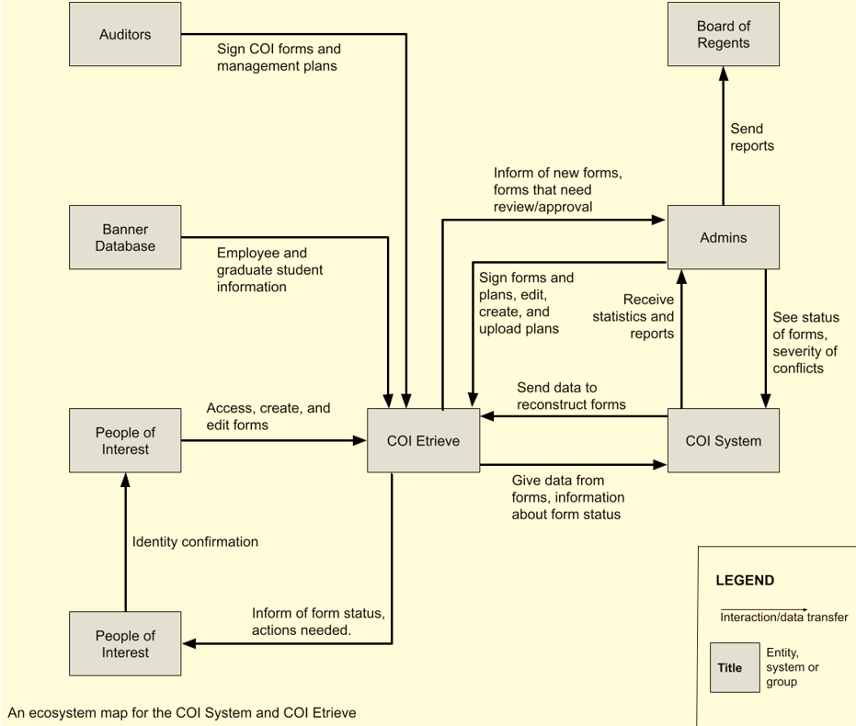
Figure 2.1 COI System Ecosystem Map
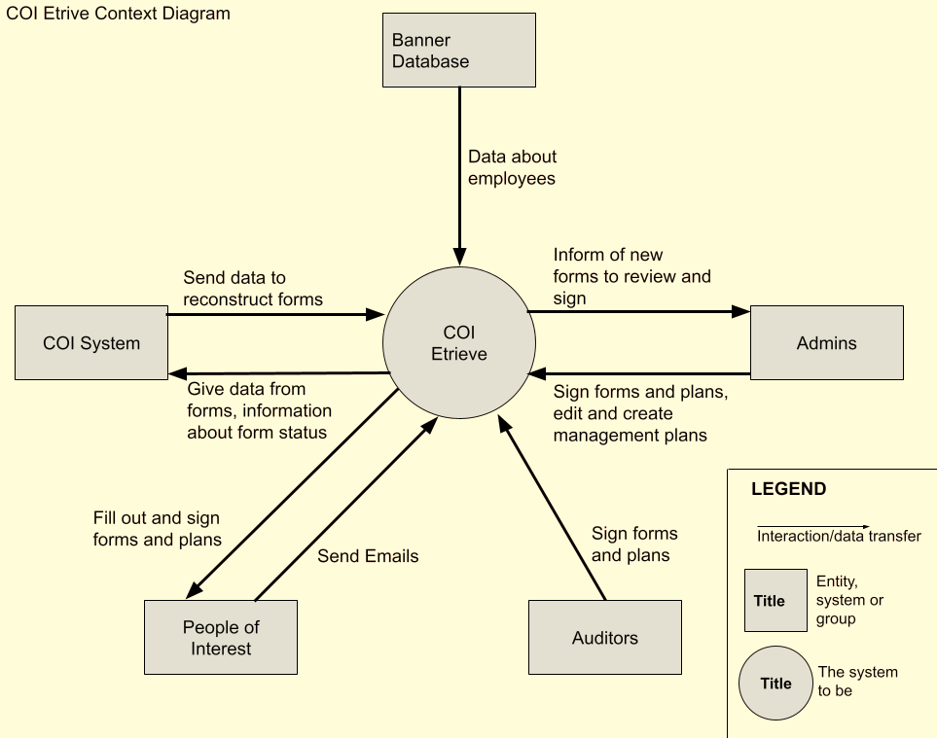
Figure 2.2 COI Etrieve Context Diagram

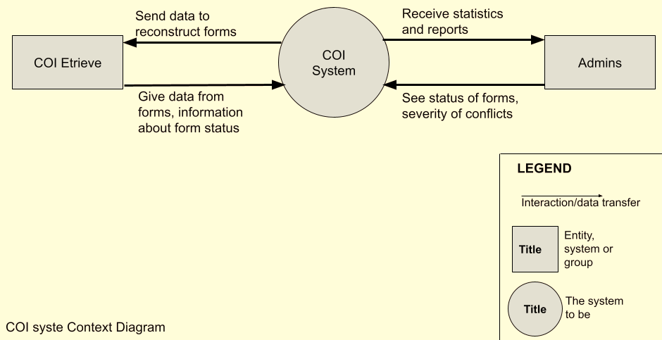
Figure 2.3 COI System Context Diagram

User Characteristic
Three types of users are involved in handling conflicts of interests. Some of these users interact with COI Etrive (see Table 2.1 COI Etreive User Classes), while others interact with the COI System (see Table 2.2 COI System User Classes).

Although the system will generate reports for the Board of Regents to comply with state laws, the Board of Regents will never interact with the system directly or indirectly. They will only receive the report the system generates. As such, they are not represented in the table.

User Class | Description
Auditor | An external individual at the University of Montana who only has the ability to sign a select few COI forms.
Admin | Individuals in the Research Office that can approve, edit, and create management plans. They can also sign COI forms and management plans.
Person of Interest | Anyone who is required to complete a COI form. The person completes and submits COI forms, as well as providing an explanation for any conflicts. (Note that an Admin user will also be a Person of Interest, as Admins need to sign COI forms as well.)
Table 2.1 COI Etreive User Classes

User Class | Description
Admin | Individuals in the Research Office that can review other’s forms, their status, and the severity of their conflict (if one exists). They will also be able to generate status reports and yearly reports to comply with state law.
Table 2.2 COI System User Classes

Dependencies
The COI System is dependent on Etrieve through which all COI forms and conflict management plans will be populated and signed. After their completion, these forms will be stored in the COI System, from which Admins can view them and generate statistics and reports.

The COI System is dependent on the Single Sign-On System, of Montana Tech.

The system will be dependent on Banner for the legal names of employees and graduate students engaged in research.

Assumptions
Some assumptions for this system are:
- Auditors will not have any interaction with the COI System. They will only interact with COI Etrieve to sign a select few forms.
- People of Interest are employees with greater than one-half FTE or graduate students engaged in research.
- All actual conflicts of interest will be managed by the Research Office. The COI System will not manage conflicts, it simply stores information on conflicts and how those conflicts will be managed.
- This system will be available on any computer with a modern web browser and Internet connectivity.
- The Vice Chancellor of Research is unable to sign their own COI form and is also unable to sign the forms of the Chancellor and Provost. As such, someone from The University of Montana must assume the role of Auditor and sign their forms.

Use Cases
This subsection contains use cases of the proposed system. Some of these use cases are implemented as part of COI Etrieve, while others are for the COI System.

Three types of users are involved in handling conflicts of interests. Some of these users interact with COI Etrive (see Table 2.1 COI Etreive User Classes), while others interact with the COI System (see Table 2.2 COI System User Classes).

COI Etrieve Actor
This section lists the actors that will interact with the COI Etrieve, along with the interactions that these actors may perform. An actor is a person, or other entity external to the software system, who may interact with the proposed system to accomplish tasks.

Primary Actor | Use Cases
Auditor | Approve Management Plans
Admin | Create/Edit Management Plans  Admin/Auditor Signature
Person of Interest | Create/Edit Form  Aid in Management Plans
Table 3.1 Actors Table

COI Etrieve Use Cases
The following use cases outline, from a user’s point of view, the COI Etrieve behavior as it responds to user interactions. Each use case is represented as a sequence of steps, beginning with a user’s goal, and ending when that goal is fulfilled, or the user has exited the use case.

The use cases are given in the order in which they are occur.

Create/Edit Form
Created By: | Nathan Blankenship | Last Updated By: | Class
Date Created: | 03/21/2021 | Date Last Updated: | 4/10/2022
Actors: | Person of Interest
Description: | User fills out, submits, and signs a COI form
Preconditions: | The User needs to complete a COI form
Postconditions: | - User’s form is complete.  - User has signed their form.
Normal Flow: | 1.0 Create Form  - User visits the system from the annual email.  - User is directed to MTech Single Sign-On, where they log in.  - The system informs the user of their rights and responsibilities in disclosing conflicts of interest through the terms of service.  - The user agrees to the terms of service.  - The system shows them the rest of the form.  - User fills out the form honestly, signs, and submits.  - The system receives their form and updates its status.
Alternative Flows: | 1.1 Create from Single Sign-On  - User visits the system directly from MTech Single Sign-On.  - Return to step 2.  1.2 User decides to save the partially completed form, and complete it later  1. The user fills out the form partially and then indicates they would like to stop editing.  2. The system prompts for confirmation, saves the form, and then exits.  3. The user returns to the system, either through another email prompt or via Single Sign-On.  4. The system loads the unfinished form.  5. Return to step 5.
Exceptions: | E.1 Terms and Conditions are not Agreed to  If for any reason a POI chooses not to accept the systems Terms of Service, the system will deny the user access to sign the form.
Includes/Extends: | None
Priority: | Imperative
Frequency of Use: | High
Business Rules: | BR-1, BR-3
Special Requirements: | The COI forms of the Vice Chancellor of Research, Chancellor, and Provost (and possibly others) must be signed by the appropriate person at the University of Montana assuming the role of auditor. The PoI must sign using their legal name as defined in Banner.
Assumptions: | None.
Notes and Issues: | None.

Aid in Management Plans

Created By: | Brandon Mitchell | Last Updated By: | Class
Date Created: | 3/6/2022 | Date Last Updated: | 4/10/2022
Actors: | Person of Interest
Description: | When a user has indicated a possible conflict of interest exists, the system will generate a management plan tailored to them and their situation.
Preconditions: | - The user is currently signed in.  - The user is currently filling out a COI form.  - The user indicated a possible conflict of interest exists.
Postconditions: | - A tailored management plan exists for the user.
Normal Flow: | 1.0 Generate a Management Plan  - The user selects possible conflicts from a list.  - The system prompts for an explanation.  - The user provides an explanation. (Trevor stated supporting documentation would be difficult and the Research Office people said it wasn’t needed/didn’t want to deal with extra files).  - The system receives their input and asks, “Is there anything else we need to know?” as a catch all.  - The user provides additional details.  - The system receives their input.  - The user signs and submits the form.  - The system receives their form and updates its status.  - The system generates a default management plan based on the user input and sends it to the Admins for review.  - The system informs the user once their management plan is ready.  - The user signs their management plan.  - The system records their signature and updates the form status.
Alternative Flows: | 1.1 Remove Conflicts (branch after step 1)  - The user decides to remove all possible conflicts.  - The system updates the form to match their input.  - The user signs and submits the form.  - The system receives their form and updates its status.  1.3 Complicated Conflicts (branch after step 8)  - The user has complicated conflicts and a form cannot be generated.  - The system forwards their form to the Admins to manually create management plan.  - The Admins add the user’s form to the system or creates one within the system.  - The system informs the user their management plan is ready and updates its status.  - Return to step 10.
Exceptions: | None.
Includes/Extends: | Extends Create Form use case. Includes Manage Management Plans use case.
Priority: | Critical
Frequency of Use: | Used whenever the user indicates a possible conflict exists.
Business Rules: | None.
Special Requirements: | None.
Assumptions: | - Assumes the “Lego blocks” idea is possible and can be implemented.  - An Auditor may sign off on a management plan if needed.
Notes and Issues: | A management plan requires the signature of the user and the signature of an Admin to be considered complete. The Admin or Auditor will only sign the plan after the user has signed.

Create/Edit Manage Management Plans

Created By: | Brandon Mitchell | Last Updated By: | Class
Date Created: | 4/5/2022 | Date Last Updated: | 4/10/2022
Actors: | Admin
Description: | Admins are able to edit, create, and send out management plans.
Preconditions: | - The user is currently signed in.  - A PoI has completed their COI form and one or more of their conflicts requires a management plan.
Postconditions: | The PoI will have access to their management plan.
Normal Flow: | 1.0 Edit Management Plan  - The user accesses a PoI’s management plan.  - The system displays the auto-generated management plan.  - The user is able to make edits and additions as they see fit.  - The system records the edits and additions.  - The system sends the form to the associated PoI.
Alternative Flows: | 1.1 Create Management Plan (branch after step 1)  - The system indicated no plan has been created.  - The user is able to create a plan or upload a plan written in another system such as MSWord.  - Return to step 3.  1.2 Send to Another Admin (branch after step 4)  1. The user chooses to send the form to another Admin for review.  2. The system prompts for the user to select the recipients.  3. The user selects the recipients and sends the form.  4. The system sends the form to the selected recipients.
Exceptions: | None
Includes/Extends: | None
Priority: | Critical
Frequency of Use: | Used whenever a management plan needs to be sent out.
Business Rules: | None.
Special Requirements: | While an Admin can create and edit their own management plan, an external person is required to sign off on that management plan.
Assumptions: | None.
Notes and Issues: | None.

Approve Management Plans
Created By: | Tucker Kane | Last Updated By: | Class
Date Created: | 03/21/2022 | Date Last Updated: | 4/10/2022
Actors: | Auditor
Description: | User uses COI Etreive to sign off on completed COI forms or management plans.
Preconditions: | - A Person of Interest has completed their COI form or management plan and that form is ready for approval.  - The user is signed in.
Postconditions: | The COI form for the user has been approved or rejected.
Normal Flow: | - Sign COI form or management plan  - The system presents the user with submissions that need signatures.  - The user selects a submission, reviews, it, and then signs it to approve it.  - The system records their signature and updates the submission status.
Alternative Flows: | 1.2 Form or plan is rejected (branch after step 1)  - The user selects a submission, reviews, it, and rejects it.  - The user attaches comments explaining their rational behind the rejection.  - The system records the rejection and comments and updates the submission status.  - The system informs the Person of Interest their submission was rejected and needs to be modified.
Exceptions: | None
Includes/Extends: | None
Priority: | Critical
Frequency of Use: | Used whenever a specific PoI (may also be administrator) indicates a possible conflict exists.
Business Rules: | BR-1, BR-2, BR-3, BR-4
Special Requirements: | None.
Assumptions: | None.
Notes and Issues: | The Auditor will be the last one to sign a COI form or management plan.

COI System Actor
This section lists the actors that will interact with the Etrieve Forms, along with the interactions that these actors may perform.

Primary Actor | Use Cases
Admin | Dashboard Use Case  Generate Report
Table 3.1 Actors Table

COI System Use Cases
The section outlines, from a user’s point of view, the COI System behavior as it responds to user interactions.

Dashboard Use Case

Created By: | Matthew Gallagher | Last Updated By: | Class
Date Created: | 3/6/2022 | Date Last Updated: | 4/10/2022
Actors: | Admin
Description: | Enable users to discover information about the progress of completing COI forms and information about conflicts in general.
Preconditions: | The user is signed into the COI System.
Postconditions: | None, that is, no changes have been made to the COI system data.
Normal Flow: | 1.0 Description Phrase  1. The user navigates to the dashboard.  2. The system displays the status of COI forms and other relevant information.  3. The user can select various filter criteria to learn about conflicts and the status of the forms, as well as generating an annual report.  4. The system updates the displayed forms to comply with the filters.
Alternative Flow: | 1.1 Search (branch after 2)  1. The user enters a name to search for.  2. The system updates the displayed forms to show any matching forms.
Exceptions: | None
Includes/Excludes: | None
Priority: | Critical
Frequency of Use: | Used frequently by the Admins to monitor status of COI forms
Business Rules: | None
Special Requirements: | None
Assumptions: | None
Notes and Issues: | None

Generate Report
Created By: | Matthew Gallagher | Last Updated By: | Class
Date Created: | 3/6/2022 | Date Last Updated: | 4/10/2022
Actors: | Admin
Description: | A user generates a status report or an annual report.
Preconditions: | The user must be signed in as an Admin of the COI System.
Postconditions: | Generated report can be viewed or downloaded.
Normal Flow | 1.0 Generate Status Report  1. The user prompts the system to generate a status report  2. The system displays options for types of reports  3. The user selects the type of report they would like  4. The system generates the report, and it can be viewed or downloaded
Alternative Flows: | 1.1 Generate Annual Report (branch after step 2)  1. The user chooses to generate the annual report  2. The system generates a legally compliant annual report (number of People of Interest, total conflicts, major and minor, etc.), and it can be viewed or downloaded.  1.2 Retrieve Annual Report (branch after step 2)  1. The user chooses to retrieve an annual report.  2. The system prompts the user for the desired year.  3. The user selects the desired year.  4. The system retrieves the annual report, and it is can be viewed or downloaded.
Exceptions: | E.1 Specified Year is not in the System  - The system informs the user the selected year is not available.  - Return to step 2.
Includes/Extends: | None
Priority: | Imperative
Frequency of Use: | Low, at least once a year
Business Rules: | BR-6
Special Requirements: | None.
Assumptions: | - Annual reports are generated at the end of the year when all forms are completed.  - Annual reports are saved in the COI system for later review and audit.
Notes and Issues: | Generating status reports is set as the normal flow as status reports are likely to be created several times a year while the yearly report will likely only be created once.

Specific Requirements
The following section contains all of the requirements for the COI System and COI Etrieve. The details within this section are defined as individual, specific requirements. Each requirement is tagged with a priority to indicate its importance. In order from least importance to most importance, the possible priority levels are: low, medium, high, and critical. Each requirement is clearly identified for tracking.

Functional Requirements
[This subsection should specify how the software product will react to every possible input situation. It describes all the actions that must take place in the software in response to every input. Pertinent changes in the environment are considered to be inputs.

Care must be taken to avoid dropping into design details. In the user cannot directly experience the effect of a requirement it probably crossed the line into design.

Functional requirements should be logically grouped. Each group should have a short, unique (within the SRS) abbreviation and a number. The word processing section number will probably change as the SRS is developed.

For each identified requirement an optional rationale for that requirement may be given.

Most modern software should provide at least a modicum of user help. For very complex applications in situ help may be supplemented by a user’s manual (or manual page) but for many simple applications comprehensive in situ help is sufficient.]

Quality Attributes
[This subsection specifies criteria used to judge the operation of a system, rather than specific behaviors of the system. Specify the specific behavior of the system in the functional requirements.]

Availability

Human Factors
[Not everyone has the same inherent mental and physical capabilities vis-à-vis a given computer application. For example if sound is part of the application, will other clues be given that will enable a hard of hearing user to use the proposed application as well as person with normal hearing; similarly for color blindness. Define these factors, if necessary, with validation criteria.]

Usability

Performance

Security

Reliability
[Reliability is specified as mean-time-to failure of an operational item. An operational profile must be specified.]

Maintainability

Enhanceability/Extendibility
[If the future it might be necessary to change the Functional requirements in specified ways, what is the maximum estimated effort required to make such changes and what is the rationale for this estimate?]

Portability
[If in the future it might be necessary to change the above Development or Delivery Environments (DV or DL) to other specified environments, what is the maximum estimated effort required to implement such changes and what is the rationale for this estimate]

V&V Activities

Adaptability
[If it is specified that in the future it might be necessary to change any of the above Non-Functional requirements, what is the maximum estimated effort required to implement such changes and what is the rationale for this estimate.]

Non-Functional Requirements Which Are Not Quality Attributes
[This subsection specifies non-functional criteria such as platform, deployment, interface, design and document requirements. If there is not a document describing project requirements, those requirements (cost, schedule, etc.) can be placed here.]

External Interface Requirements

Hardware

Software

Communications

Development Environment

Delivery Environment

Site
[This subsection should specify any requirements for installation or operation of the software that might change the pre-existing configuration of the user site.]

Operations
[This subsection should specify normal and special operations required by the user to include:
- Various modes of operation within the user organization
- Periods of interactive operations and unattended operations
- Data processing support functions
- Backup and recovery operation.]

Design Constraints
[Sometimes a client will require certain design constraints, for example the use of a certain system configuration or the use of particular algorithm. Such constraints are described in this subsection.]

Database
[This optional subsection specifies requirements for any database to be developed as part of the product. The information in this section may include:
- Types of information to be stored
- Table attributes (queried, supporting, updated)
- Frequency of access
- Accessing capabilities and requirements
- Data elements and file descriptors
- Retention requirements for data.]

Take care to avoid design details. Unless so requested by the client, this section should only contain as much information about saved data as is necessary to fully document any of the requirements given above.]

Deliverable Items, Dates and Conditions

Cost

Standards

Future Enhancements
It is not expected that there will be any future enhancements to this product.

Appendices
These appendices provide detailed information to aid in understanding the COI Etrieve and the COI System.

Appendix A: Analysis Models
Models help to clarify the requirements. The following model shows the states of a COI form and a conflict management plan and the events that take the plan from one state to another. The states are show together, and any state combination not represented is not possible.

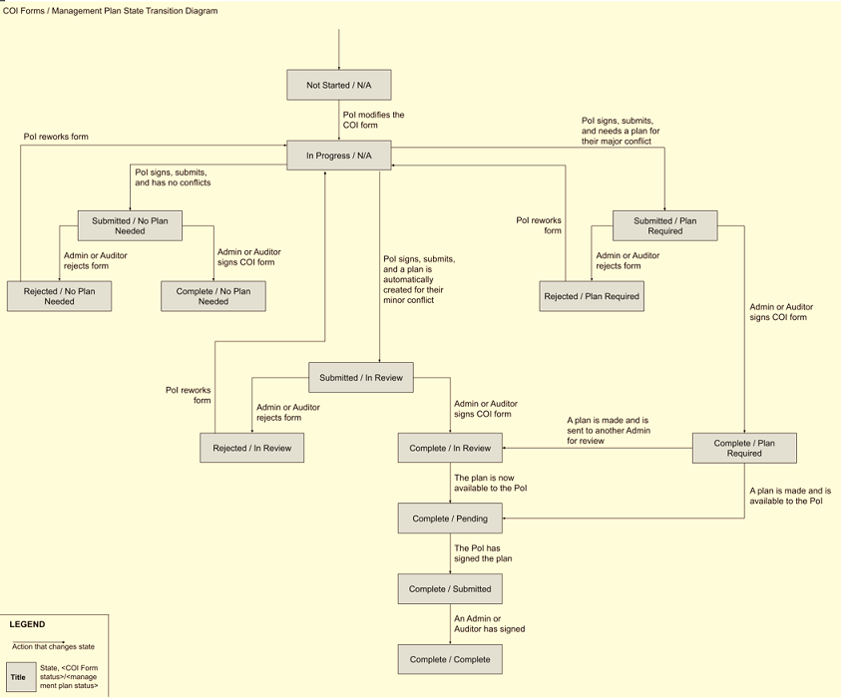
Figure 0.1 Form and Management Plan State Transition Diagram

Appendix B: Data Dictionary
[The data dictionary defines the composition of data structures and the meaning, data type, length, format, and allowed values for the data elements that make up those structures. In many cases, storing the data dictionary as a separate artifact, rather than embedding it in an SRS is beneficial. This also increases its reusability potential in other projects.

List data items alphabetically. Make each name a bookmark so each time the name occurs in this SRS it can be link to this entry via a hyperlink. Choose names with care. The expectation is that these names will persist in the design and implementation.]

Data Element | Description | Composition or Data type | Length | Values
Name of data item being defined | Textual description of the business meaning of the data element | For primitive data elements: data type (integer, floating point, alphabetic, date, etc.) and, as appropriate, format (e.g. date as MM/DD/YYYY).  For data structures show the components that comprise the structure. , | Maximum number of characters for primitives; blank for structures | List of allowed values, default, rules governing legal values, and any other description of the data values
… | … | .. | … | …

Appendix C: Report Specification
Yearly reports are required to be generated and sent to the Montana Board of Regents in compliance with the 1998 COI Policies. This report is to include:
- The total number of individuals who were required to fill out a COI form
- The number of people that actually completed and submitted the form,
- The Number of conflicts disclosed (and how they differed from last year’s response)
- A summary of the conflicts
- How many conflicts are being managed through written plans
- The number of conflicts eliminated

The 2021 yearly report below serves as a great example what needs to be included and how everything should be formatted.

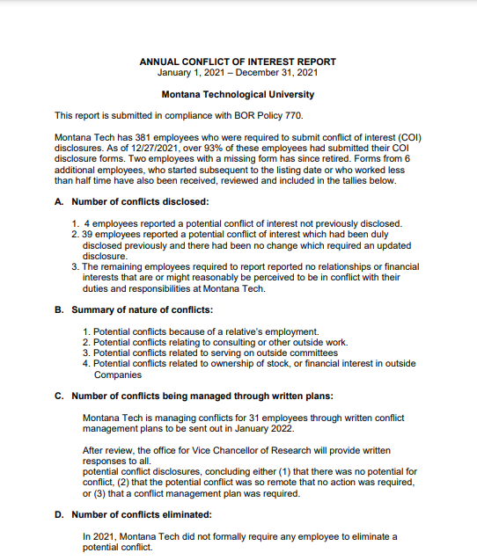

Figure 0.5 TechAnnual_COI_Report_2021.pdf

Appendix D: Business Rules
Several business rules relevant to the COI System are identified in this appendix.

ID | Rule Definition | Type of Rule | Static or Dynamic | Source
BR-1 | Every conflict form (aside from the Chancellor’s and the Vice Chancellor of Research) must be signed by the Vice Chancellor of Research and the person filling out the form in order to be considered complete. | Fact | Static | COI Policy, 1998
BR-2 | Employees working over one-half FTE a week, along with graduate students engaged in research, must complete a COI form. | Fact | Static | Montana Tech Faculty/Staff Handbook
BR-3 | Compliance of COI policy is required by all full-time and part-time Montana Tech employees, including students who receive compensation from Montana Tech and students or others who design, conduct, or report research, educational, or public service activities for Montana Tech | Fact | Static | Montana Tech Faculty/Staff Handbook
BR-4 | Research administrators cannot review and approve their own COI form | Fact | Static | COI Policy, 1998
Table 0.1Business Rules

Appendix E: Sample User Interface
The following is a sample user interface of the COI system. Users will be able to generate reports, filter by status, and view a form’s current status.
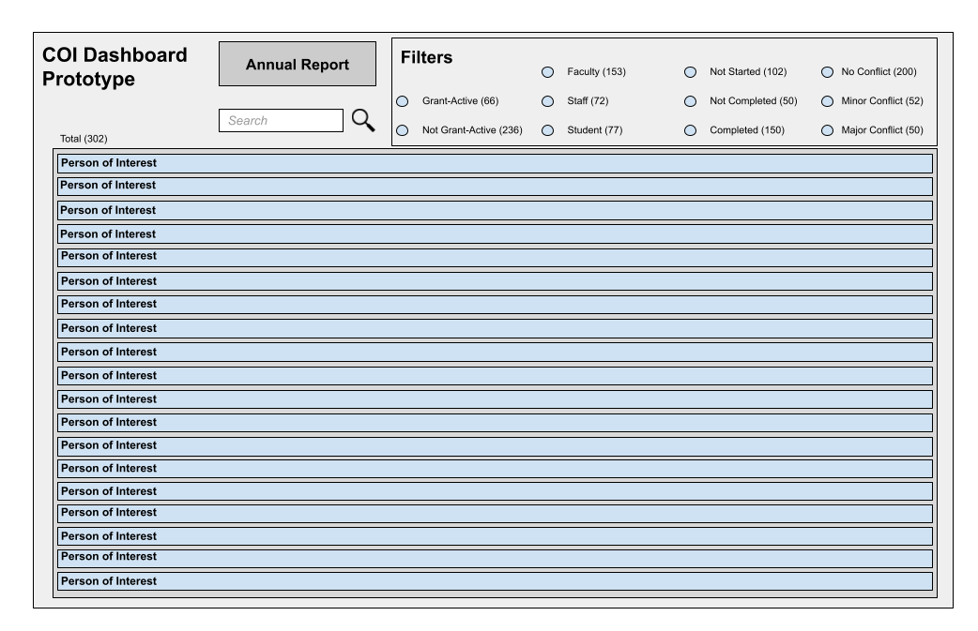
Figure 0.6 UI Prototype

Appendix F: Issues
[This optional appendix is a dynamic list of the open requirements issues that remain to be resolved, including TBDs, pending.]

