Conflict of Interest System
MTM Program Product
Software Requirements Specification

Version 0.3
3/23/2022

Template Version 3.5

Standard Version Number: 3.5
Standard Version Date: March 10, 2018
Version History
Version | Date | Authors | Comment
0.1 | 2/18/2022 | Students of Req & Spec, Spring 2022 - Nathan Blakenship, Matthew Gallagher, Tucker Kane, Brandon Mitchell | Introduction: business objectives, vision, context, environment
0.2 | 3/4/2022 | Same as above | General factors: functions/features, users
0.3 | 3/23/2022 | Same as above | Incorporate Etrieve into handling conflicts, added use cases and other details

Template Version History
Version | Date | Authors | Comment
3.0 | 7/21/2012 | Frank Ackerman | Initiating standards versions
3.1 | 8/2/2012 | Frank Ackerman | Some non-functional requirements definitions. Added Adaptability, Enhanceability, and Portability
3.2 | 1/17/2013 | Frank Ackerman | Added usability comment
3.3 | 3/6/2013 | Frank Ackerman | Added a bit more explanatory text and final section 8.
3.5 | 3/10/2018 | Celia Schahczenski | Changed format of dates, rearranged, renamed items, removed Illustrative Use Cases, increased some explanations, added appendices including data and report sections.

Montana Tech Software Engineering Students:
These Montana Tech Method software engineering standards encapsulate Dr. Ackerman’s decades of experience in the software industry, the IEEE software engineering standards, and many suggestions from various texts. They have gone through many revisions and additions over the last several years. They are part of your software engineering studies so that (1) you may have the experience of developing software to a standard (which you may find you need to do if you take a job that requires high reliability software), and so that (2) you will have the experience of developing high quality software. You are also invited to participate in the continuing evolution of these standards by studying them critically and making suggestions for their improvement and correction.

TABLE OF CONTENTS
1 Introduction 6
1.1 Software Purpose and Scope 6
1.2 Document Purpose and Contents 6
1.3 Definitions, Acronyms, Abbreviations and References 7
1.3.1 Definitions 7
1.3.2 Acronyms and Abbreviations 8
1.3.3 References 8
2 General Factors 9
2.1 Product Perspective 9
2.2 Environmental Conditions 9
2.3 User Characteristic 11
2.4 Dependencies 12
2.5 Assumptions 12
3 Use Cases 13
3.1 Etrieve Forms Actor 13
3.2 Etrieve Forms Use Cases 13
3.2.1 Aid In Conflict Management 13
3.2.2 Create Form 14
3.2.3 Admin Signature 15
3.2.4 Auditor Signature 16
3.3 COI System Actor 17
3.4 COI System Use Cases 17
3.4.1 Dashboard Use Case 17
3.4.2 Current fiscal year progress report 18
3.4.3 Report 19
4 Specific Requirements 20
4.1 Functional Requirements 20
4.2 Quality Attributes 20
4.2.1 Availability 21
4.2.2 Human Factors 21
4.2.3 Usability 21
4.2.4 Performance 21
4.2.5 Security 21
4.2.6 Reliability 21
4.2.7 Maintainability 21
4.2.8 Enhanceability/Extendibility 21
4.2.9 Portability 21
4.2.10 V&V Activities 21
4.2.11 Adaptability 21
4.3 Non-Functional Requirements Which Are Not Quality Attributes 21
4.3.1 External Interface Requirements 22
4.3.2 Development Environment 22
4.3.3 Delivery Environment 22
4.3.4 Design Constraints 22
4.3.5 Database 22
4.3.6 Deliverable Items, Dates and Conditions 23
4.3.7 Cost 23
4.3.8 Standards 23
5 Future Enhancements 23
Appendices 24
Appendix B: Analysis Models 24
Appendix C: Data Dictionary 24
Appendix D: Report Specification 25
Appendix E: Business Rules 26
Appendix F: Sample User Interface 27
Appendix G: Issues 27

Table of Figures
Figure 2.1 COI System Ecosystem Map 10
Figure 2.2 COI System Context Diagram 11
Figure 0.1Conflict Management Plan State Transition Diagram 24

Table of Tables

Table 1.1 Definitions 7
Table 1.2 Acronyms 8
Table 2.1 Etreive Forms User Classes 12
Table 2.2 COI System User Classes 12
Table 0.1Business Rules 27

Introduction
This section provides an overview of the Conflict of Interest (COI) System, the purpose of this document, and definitions, acronyms and references related to conflicts of interest.

Software Purpose and Scope
The purpose of the Conflict of Interest System (COI) System is to help the Research Office handle conflicts of interest for Montana Technological University (subsequently known as Montana Tech). For Montana Tech affiliated members who fall under the COI policy, the COI System is an interactive user interface, storage, and reporting system that will reduce user and staff input to less than 40 hours per year, guarantee a 95% or better completion rate for all faculty and staff, and generate annual reports. Unlike the previous systems used by the research office, this system accurately collects statistics, chooses correct recipients, saves time, educates users on the COI policy, and generates reports.

Document Purpose and Contents
The purpose of this Software Requirements Specification (SRS) is to give readers an understanding of Montana Tech’s goals and needs for a COI System. It provides a guide for future developers on the desired features, functionality and behaviors of the COI System. This document can be used to design tests to ensure an implementation behaves as intended.

Customers sometimes find sample interfaces easier to understand than documents such as this SRS. Sample user interfaces demonstrate one way that the software could appear. This document goes further to tell precisely what functionality is needed.

This document does not attempt to tell how this software should be implemented except in those cases where the customers want the application to be developed in a particular way. Deciding exactly what a system should do, before deciding how it will do it, reduces development time considerably.

This SRS was developed by students in Software Requirement and Specification (ESOF 328), in the Spring 2022 at Montana Tech. It has been developed in part by faculty members, administrative personal and students. Thanks goes to Angela Lueking, Jill Yoder, Muhammad Abdul Basit UR Rahim, Trevor Osborne, and Ryan Hessler. The main audience of this document are the clients as well as the developers that will use this document to implement the system.

Definitions, Acronyms, Abbreviations and References
This section defines technical terms used in this document, as well as the expansions of acronyms and abbreviations, and important references.

Definitions
This subsection contains definitions of terms used in this document.

Conflict of interest and financial disclosure | Occurs “…when there is a potential divergence between the employee’s private interests and professional obligations to Montana Tech, such that an independent observer might reasonably question whether the employee’s professional actions or decisions could be influenced by considerations of personal gain (financial or otherwise).” From the Conflict of Interest and Financial Disclosure policy
Status of COI form | COI forms can have one of the following distinct statuses:  - Not Started: The Person of Interest has not started or modified their form.  - In Progress: The Person of Interest has made changed to their form but hasn’t submitted it yet.  - Submitted: The Person of Interest has signed and submitted the form for review by the Admins.  - Pending: A management plan has been created for one or more conflicts, but the Person of Interest has not yet signed their management plan (see the “Created” status of the management plan below).  - Complete: The form has been reviewed and signed by an Admin or Auditor.
Status of management plan | Management plans can have one of the following distinct statuses:  - No Plan Needed: No conflict exists, so no plan is needed.  - In Review: Form is either being reviewed or created by Admins.  - Created: The form was created by the COI system or the Admins and exists.  - Signed: The form has been signed by the Person of Interest.  - Complete: The form has been signed by both the Person of Interest and an Admin or Auditor.
Bins | Each completed COI form will be put into one of the following “bins” for filtering by the Admins:  - No Conflict  - Minor Conflict  - Major Conflict
Table 1.1 Definitions

Acronyms and Abbreviations
Acronyms and abbreviations found in this document are included in this subsection.

COI | Conflict of Interest
FTE | Full-Time Equivalent, a designation of workload for faculty members or students. For faculty members, 1.0 FTE = 40 hours. For students during the academic year, 1.0 FTE = 20 hours.
PoI | Person of Interest, anyone who will be using the COI System to sign a conflict of interest form
SRS | Software Requirements Specification, term used for this document
SSO | Single Sign-On, the secure login system commonly used for Montana Tech applications
Table 1.2 Acronyms

References
References relevant to the Conflict of Interest System are given in this subsection.

Banner
https://www.ellucian.com/solutions/ellucian-banner-human-resources

Conflict of Interest and Financial Disclosure Policy (1998), Montana Technological University,
https://www.mtech.edu/research/files/conflict-interest-financial-disclosure.pdf

Conflict of Interest Disclosure Statement and Certification Portal, Montana Technological University, https://mtlbsso.mtech.edu/idp/profile/cas/login?execution=e1s1

Etrieve
https://www.softdocs.com/etrieve

Montana Technological University Faculty/Staff Handbook
https://www.mtech.edu/facultystaff/fac-staff-handbook-acc.pdf

General Factors
A high-level overview of what the COI System will do, its running environment, who will use it, its dependencies, and assumptions made about it are included in this section.

Product Perspective
This system is meant to serve as a replacement to the current COI process. In addition, this project will be dependent on the Etrieve, Banner and Single Sign-On systems of Montana Tech.

Product Functions to handle Conflicts of Interests.
Etreive COI forms will:
- Educate: Etrieve forms will educate users on what is a conflict of interest, the importance of disclosing conflicts, and the consequences of not properly disclosing information on the form.
- Create: Etrieve forms will enable People of Interest to complete, sign, and submit COI forms online, approving the document with their digital signature.
- Sign forms: Etrieve forms will allow certain individuals to sign off on COI and management plan forms

The COI System will:
- Manage forms: The system will aid Research Office personnel to easily see the status of all COI forms.
- Aid in conflict management: The system will aid Research Office personnel to easily see who has potential conflicts, the status of those conflicts, and to record how those conflicts will be managed.
- Filter: Filter completed COI forms into distinct bins that can be reviewed by the Research Office.
- Report: The system will generate yearly reports on the data gathered from the signed COI forms to submit to Montana Tech’s Board of Regents. Status reports can also be made at any time.

Environmental Conditions
The Montana Board of Regents requires the submission of annual conflict of interest reports from each of its universities, including Montana Tech. Banner holds the information necessary to uniquely identify employees and graduate students engaged in research. Etrieve will be used to create and complete COI and management plan forms. Microsoft Outlook is the most likely tool to be used to distribute COI forms as each employee and student has their own unique email address. COI System authorization will be Montana Tech’s Single Sign-On (SSO) System. Figure 2.1 COI System Ecosystem Map shows the interactions of the COI System. Figure 2.2 COI System Context Diagram shows the context in which the COI System will operate.

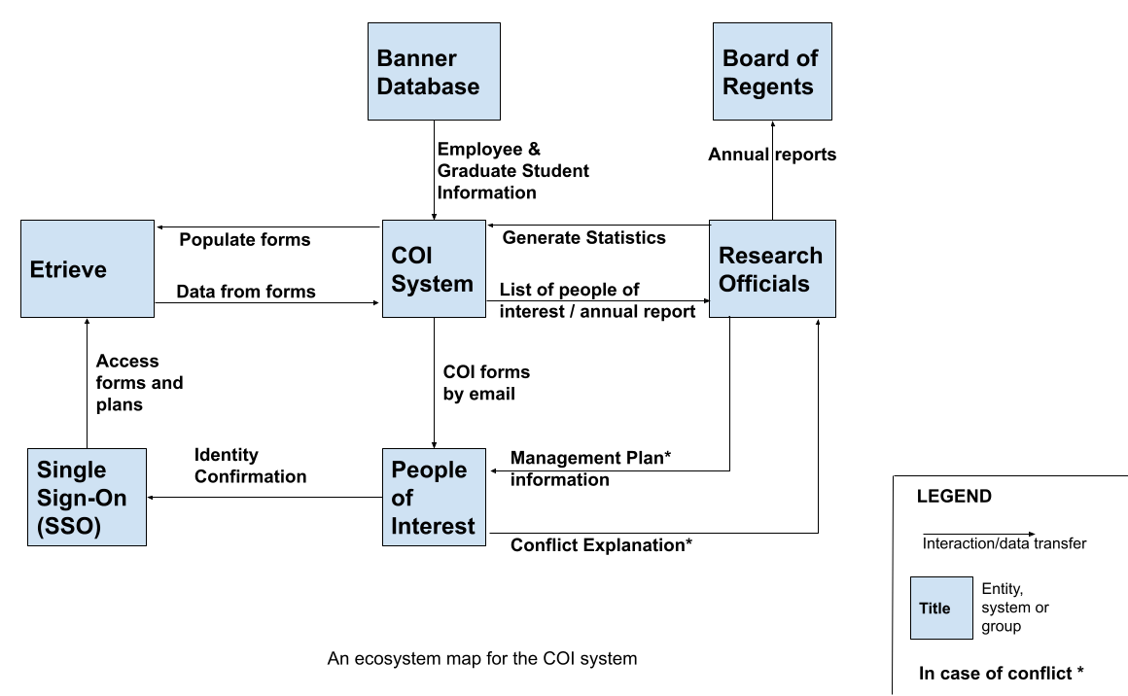
Figure 2.1 COI System Ecosystem Map

I expect People of Interest to only interact with the Etrieve forms, not with the COI System.

Are two context diagrams needed: one for Etreive Forms and another for the COI System?
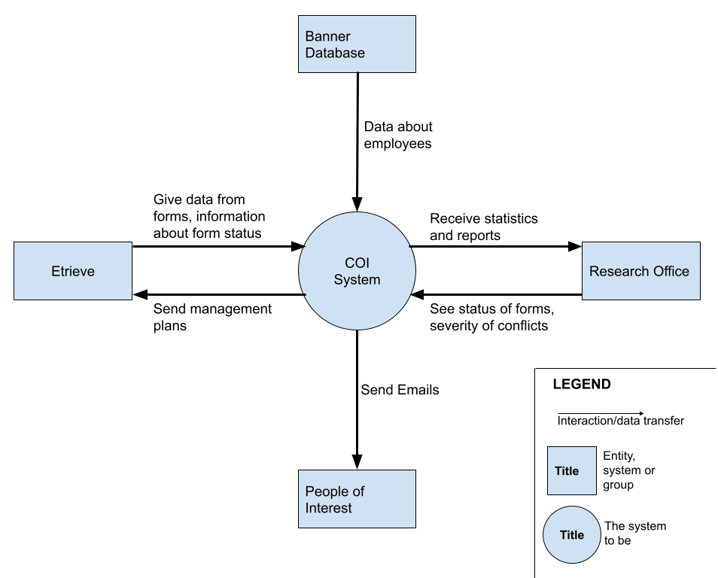
Figure 2.2 COI System Context Diagram

User Characteristic
Three types of users are involved in handling conflicts of interests. Some of these users interact with Etrive Forms (see Table 2.1 Etreive Forms User Classes), while others interact with the COI System (see Table 2.2 COI System User Classes).

Although the system will generate reports for the Board of Regents to comply with state laws, the Board of Regents will never interact with the system directly or indirectly. They will only receive the report the system generates. As such, they are not represented in the table.

User Class | Description
Auditor | Individual at the University of Montana who can sign off on COI forms of Montana Tech administrators. The only interaction with the system of these external individuals is to sign COI forms. These people will never be Admins or a Person of Interest.
Person of Interest | This is anyone who is required to complete a COI form. The person completes and submits COI forms, as well as providing an explanation for any conflicts. (Note that an Admin user will also be a Person of Interest, as Admins need to sign COI forms as well.)
Table 2.1 Etreive Forms User Classes

User Class | Description
Admin | Individuals in the Research Office that can review other’s forms, their status, the severity of their conflict (if one exists), and sign off on forms. They will also be able to generate status reports and reports to comply with state law.
Table 2.2 COI System User Classes

Dependencies
The COI System is dependent on Etreive through which all COI forms and conflict management plans will be populated and signed. After their completion, these forms will be stored in the COI System, from which Admins can view them and general statistics and reports.

The COI System is dependent on the Single Sign-On System, of Montana Tech.

The system will be dependent on Banner for the legal names of employees and graduate students engaged in research.

Assumptions
Some assumptions for this system are:
- Auditors consists of the Vice Chancellor of Research and anyone who is allowed to sign on their behalf.
- People of Interest are employees with greater than one-half FTE or graduate students engaged in research.
- All actual conflicts of interest will be managed by the Research Office. The COI System will not manage conflicts, it simply stores information on conflicts and how those conflicts will be managed.
- This system will be available on any computer with a modern web browser and Internet connectivity.
- The Chancellor and Vice Chancellor of Research are unable to sign off on their own COI forms. Therefrom, someone at the University of Montana in Missoula needs to sign off on their forms. This is why there is an Auditor user class.

Use Cases
This subsection contains use cases of the proposed system. Some of these use cases are implemented as part of Etrieve Forms, while others are for the COI System.

Three types of users are involved in handling conflicts of interests. Some of these users interact with Etrive Forms (see Table 2.1 Etreive Forms User Classes), while others interact with the COI System (see Table 2.2 COI System User Classes).

Etrieve Forms Actor
This section lists the actors that will interact with the Etrieve Forms, along with the interactions that these actors may perform. An actor is a person, or other entity external to the software system, who may interact with the proposed system to accomplish tasks.

Primary Actor | Use Cases
Auditor | Sign certain COI forms
Person of Interest | Create Form  Aid in Conflict Management
Table 3.1 Actors Table

Etrieve Forms Use Cases
The following use cases outline, from a user’s point of view, the Etrieve Forms behavior as it responds to user interactions. Each use case is represented as a sequence of steps, beginning with a user’s goal, and ending when that goal is fulfilled, or the user has exited the use case.

Aid In Conflict Management

Created By: | Brandon Mitchell | Last Updated By: | Class
Date Created: | March 6, 2022 | Date Last Updated: | March 23, 2022
Actors: | Person of Interest
Description: | When a user has indicated a possible conflict of interest exists, the system will generate a management plan tailored to them and their situation.
Preconditions: | - The user is currently filling out a COI form.  - The user indicated a possible conflict of interest exists.
Postconditions: | - A tailored management plan exists for the user.
Normal Flow: | 1.0 Generate a management plan  - The user selects possible conflicts from a list.  - The system prompts for an explanation.  - The user provides an explanation or supporting documentation.  - The system receives their input and asks, “Is there anything else we need to know?” as a catch all.  - The user provides additional details.  - The system receives their input.  - The user signs and submits the form.  - The system receives their form and informs them.  - The system generates a default management plan based on the user input and informs the user.  - The user signs their management plan.  - The system records their signature.
Alternative Flows: | 1.1 Remove Conflicts (branch after step 1)  - The user decides to remove all possible conflicts.  - The system updates the form to match their input.  - The user signs and submits the form.  - The system receives their form and informs them.  1.3 Complicated Conflicts (branch after step 8)  - The user has complicated conflicts and a form cannot be generated.  - The system forwards their form to the Admins to manually create management plan.  - The Admins adds the Person of Interest’s form to the system.  - The system informs the Person of Interest their management plan is ready.  - Return to step 10.
Exceptions: | None.
Includes/Extends: | Includes Create Form use case.
Priority: | Critical
Frequency of Use: | Used whenever a Person of Interest indicates a possible conflict exists.
Business Rules: | None.
Special Requirements: | None.
Assumptions: | - Assumes the “Lego blocks” idea is possible and can be implemented.  - An Auditor may sign off on a management plan if needed.  - We are assuming that the Admins will not want to review the management plan before it is sent out to the Person of Interest.
Notes and Issues: | A management plan requires the signature of the Person of Interest and the signature of an Admin to be considered complete.

Create Form
Created By: | Nathan Blankenship | Last Updated By: | Class
Date Created: | 03/21/2021 | Date Last Updated: | 3/23/2021
Actors: | Person of Interest
Description: | User fills out, submits, and signs a COI form
Preconditions: | - The User needs to complete a COI form
Postconditions: | - User’s form is complete  - User has signed their completed form
Normal Flow: | 1.0 Create Form  - User visits the system from the annual email  - User is directed to MTech Single Sign-On, where they log in  - Upon successful login, user is informed of their rights and responsibilities in disclosing COIs through the terms of Service.  - After agreeing to the terms of service, user has access to the COI form.  - User fills out the form honestly.  - User signs the form as confirmation.
Alternative Flows: | 1.1 Create from Single Sign-On  - User visits the system from MTech Single Sign-On  1.2 User decides to save the partially completed form, and complete it later  1. User fills out the form partially, then indicates they would like to stop editing  2. System prompts confirmation, saves the form and exits.  3. User returns to the system, either through another email prompt or via Single Sign-On  4. System stores the unfinished form
Exceptions: | E.1 Terms and Conditions are not agreed to.  If for any reason a POI chooses not to accept the systems Terms of Service, the system will deny the user access to sign the form
Includes/Extends: | None
Priority: | Imperative
Frequency of Use: | High
Business Rules: | BR-1, BR-2, BR-4
Special Requirements: | The COI forms of the Vice Chancellor of Research, Chancellor, Provost, and possibly others, must be signed by the appropriate person at the University of Montana.
Assumptions: | None
Notes and Issues: | None

Admin Signature
Created By: | Tucker Kane | Last Updated By: | Class
Date Created: | 03/21/2022 | Date Last Updated: | 3/23/2022
Actors: | Admin
Description: | User uses Etreive Forms to sign off on completed COI forms.
Preconditions: | A Person of Interest has completed their COI form and that form is ready for approval.
Postconditions: | The COI form for the user has been approved or rejected.
Normal Flow: | - Sign COI form  - The user is presented a COI form that needs approval.  - The user looks over the form, signs or rejects it and submits it to the system.  - The system informs the user that the form is signed.
Alternative Flows: | None
Exceptions: | None
Includes/Extends: | None
Priority: | Critical
Frequency of Use: | Used whenever a specific Person of Interest (may also be administrator) indicates a possible conflict exists.
Business Rules: | BR-1, BR-3, BR-4, BR-5
Special Requirements: | None.
Assumptions: | - Assume that Auditors signatures will take place as part of the COI system.
Notes and Issues: | None.

Auditor Signature
Created By: | Tucker Kane | Last Updated By: | Class
Date Created: | 03/21/2022 | Date Last Updated: | 3/23/2022
Actors: | Auditor
Description: | User uses Etreive Forms to sign off on select conflicts of interest, such as the Chancellor, the Vice Chancellor of Research, and the Provost.
Preconditions: | A Person of Interest has completed their COI form and that form is ready for approval.
Postconditions: | The COI form for the user has been approved.
Normal Flow: | - Description phrase  - The user selects possible conflicts from a list.  The system prompts for supporting documentation or an explanation.  - The system prompts for supporting documentation or an explanation.  - The Person of Interest provides an explanation of supporting documentation.  - The system receives the submission.  - The Person of Interest signs and submits the form.  - The system receives their form and informs them.  - The system generates a tailored management plan based on their input and informs the Person of Interest.  - The Person of Interest signs their management plan.  - The system records their signature.  - The system prompts and administrator to sign off on the conflict of interest.  - If the form is ready to be approved, an auditor will digitally sign off on the form.
Alternative Flows: | None
Exceptions: | None
Includes/Extends: | Includes Create Form use case and Aid in Conflict Management use case.
Priority: | Critical
Frequency of Use: | Used whenever a specific Person of Interest (may also be administrator) indicates a possible conflict exists.
Business Rules: | BR-1, BR-3, BR-4, BR-5
Special Requirements: | None
Assumptions: | - Assume that Auditors signatures will take place as part of the COI system.
Notes and Issues: | None

COI System Actor
This section lists the actors that will interact with the Etrieve Forms, along with the interactions that these actors may perform.

Primary Actor | Use Cases
Auditor
Admin | Report  Aid in Conflict Management
Person of Interest | Create Form  Aid in Conflict Management
Table 3.1 Actors Table

COI System Use Cases
The section outlines, from a user’s point of view, the COI System behavior as it responds to user interactions.

Dashboard Use Case

Use Case ID: | 3 | Use Case Name: | Dashboard
Created By: | Matthew Gallagher | Last Updated By: | Matthew Gallagher
Date Created: | March 6, 2022 | Date Last Updated: | March 21, 2022
Actors: | Administrators
Description: | The interactions between the administrator and dashboard of the COI system
Preconditions: | Admin must be signed into COI dashboard
Postconditions: | None
Normal Flow: | 1.0 Description phrase  1. The user navigates to the dashboard  2. The system displays the conflicts and forms that are submitted and signed by PoI in bins to help admins determine workload  3. The user selects the conflict to be signed off  4. The system displays the conflict information through dashboard.  5. The user determines if it can be signed off.  6. The system redirects the admin to Etrieve to sign COI.  7. The system places the form in a finished bin in the dashboard.
Alternative Flow: | 1.1 Complicated Conflicts (branch after step 4)  1. The user has complicated conflicts.  2. The system forwards their form to the admins to manually create a management plan.  3. The admin uploads the management plan.  4. The system uploads the plan to Etrieve.  5. The PoI signs the management plan through etrieve.  5. Return to step 6.
Exceptions: | None
Includes/Excludes: | None
Priority: | Critical
Frequency of Use: | Used frequently by the admins to monitor status of COI forms
Business Rules: | None
Special Requirements: | None
Assumptions: | None
Notes and Issues: | None

Current fiscal year progress report
Created By: | Tucker Kane | Last Updated By: | Class
Date Created: | 03/21/2021 | Date Last Updated: | 3/23/2021
Actors: | Admin
Description: | An administrator will access the COI system to generate a report of the COI status’s that have been completed, the conflict status, and the management plan status for each conflict.
Preconditions: | The user must be an administrator of the COI system.
Postconditions: | The report is saved in the COI system.
Normal Flow: | 1.0 Description phrase  1. The user selects the generate current fiscal year report.  2. The system displays option to filter report.  3. The system generates the statistics for the status of COI forms.  4. The system saves the status report and displays its contents.
Alternative Flows: | None
Exceptions: | None
Includes/Extends: | Includes Create Form use case.
Priority: | Critical
Frequency of Use: | Multiple times a year
Business Rules: | None
Special Requirements: | None
Assumptions: | None
Notes and Issues: | None

Report
Created By: | Matthew Gallagher | Last Updated By: | Class
Date Created: | March 6, 2022 | Date Last Updated: | March 23, 2022
Actors: | Admin
Description: | A user generates a status report or an annual report
Preconditions: | The user must be signed in as an admin to the COI System
Postconditions: | Generated report has been displayed by the COI System
Normal Flow | 1.0 Generate Status Report  1. The user prompts the system to generate a status report  2. The system displays options for types of reports  3. The user selects status report  4. The system displays the report
Alternative Flows: | 1.1 Generate Annual Report (branch after step 2)  1. The user selects generate annual report  2. The system generates a legally compliant annual report (number of People of interest, total conflicts, major and minor)  3. The system displays the generated report.  1.2 Retrieve Annual Report (branch after step 2)  1. The administrator selects retrieve annual report  2. The system allows the user to select a year for which an annual report has already been generated  3. The administrator selects the desired year  4. The system retrieves the annual report
Exceptions: | 3.2.3 E.1 Specified Year is not in the System  COI policy (1998) states that statistics must be available for 3 years prior to the current fiscal year, and at least one year since the resolution of any conflicts recorded.
Includes/Extends: | None
Priority: | Imperative
Frequency of Use: | Low
Business Rules: | None
Special Requirements: | None
Assumptions: | - All annual reports are done at the end of the year when all forms are completed  - All annual reports are saved in the COI system
Notes and Issues: | None

Specific Requirements
The following section contains all of the requirements for the COI System. The details
within this section are defined as individual, specific requirements. Each requirement is
tagged with a priority to indicate its importance. In order from least importance to most
importance, the possible priority levels are: low, medium, high, and critical. Each
requirement is clearly identified for tracking.

Functional Requirements
[This subsection should specify how the software product will react to every possible input situation. It describes all the actions that must take place in the software in response to every input. Pertinent changes in the environment are considered to be inputs.

Care must be taken to avoid dropping into design details. In the user cannot directly experience the effect of a requirement it probably crossed the line into design.

Functional requirements should be logically grouped. Each group should have a short, unique (within the SRS) abbreviation and a number. The word processing section number will probably change as the SRS is developed.

For each identified requirement an optional rationale for that requirement may be given.

Most modern software should provide at least a modicum of user help. For very complex applications in situ help may be supplemented by a user’s manual (or manual page) but for many simple applications comprehensive in situ help is sufficient.]

Quality Attributes
[This subsection specifies criteria used to judge the operation of a system, rather than specific behaviors of the system. Specify the specific behavior of the system in the functional requirements.]

Availability

Human Factors
[Not everyone has the same inherent mental and physical capabilities vis-à-vis a given computer application. For example if sound is part of the application, will other clues be given that will enable a hard of hearing user to use the proposed application as well as person with normal hearing; similarly for color blindness. Define these factors, if necessary, with validation criteria.]

Usability

Performance

Security

Reliability
[Reliability is specified as mean-time-to failure of an operational item. An operational profile must be specified.]

Maintainability

Enhanceability/Extendibility
[If the future it might be necessary to change the Functional requirements in specified ways, what is the maximum estimated effort required to make such changes and what is the rationale for this estimate?]

Portability
[If in the future it might be necessary to change the above Development or Delivery Environments (DV or DL) to other specified environments, what is the maximum estimated effort required to implement such changes and what is the rationale for this estimate]

V&V Activities

Adaptability
[If it is specified that in the future it might be necessary to change any of the above Non-Functional requirements, what is the maximum estimated effort required to implement such changes and what is the rationale for this estimate.]

Non-Functional Requirements Which Are Not Quality Attributes
[This subsection specifies non-functional criteria such as platform, deployment, interface, design and document requirements. If there is not a document describing project requirements, those requirements (cost, schedule, etc.) can be placed here.]

External Interface Requirements

Hardware

Software

Communications

Development Environment

Delivery Environment

Site
[This subsection should specify any requirements for installation or operation of the software that might change the pre-existing configuration of the user site.]

Operations
[This subsection should specify normal and special operations required by the user to include:
- Various modes of operation within the user organization
- Periods of interactive operations and unattended operations
- Data processing support functions
- Backup and recovery operation.]

Design Constraints
[Sometimes a client will require certain design constraints, for example the use of a certain system configuration or the use of particular algorithm. Such constraints are described in this subsection.]

Database
[This optional subsection specifies requirements for any database to be developed as part of the product. The information in this section may include:
- Types of information to be stored
- Table attributes (queried, supporting, updated)
- Frequency of access
- Accessing capabilities and requirements
- Data elements and file descriptors
- Retention requirements for data.]

Take care to avoid design details. Unless so requested by the client, this section should only contain as much information about saved data as is necessary to fully document any of the requirements given above.]

Deliverable Items, Dates and Conditions

Cost

Standards

Future Enhancements
[This section should describe any future enhancements that are contemplated at the time this SRS completed. If there is no known possibility that this product will be enhanced in the future this section should read : It is not expected that there will be any future enhancements to this product.]

Appendices
[In some cases, it is helpful to move items out of the main portion of the Software Requirements and Specification Document. These items can appear here. Alternatively, move these items into the main part of the document.]

Appendix B: Analysis Models
Models help to clarify the requirements. The following model shows the states of a conflict management plan and the events that take the plan from one state to another.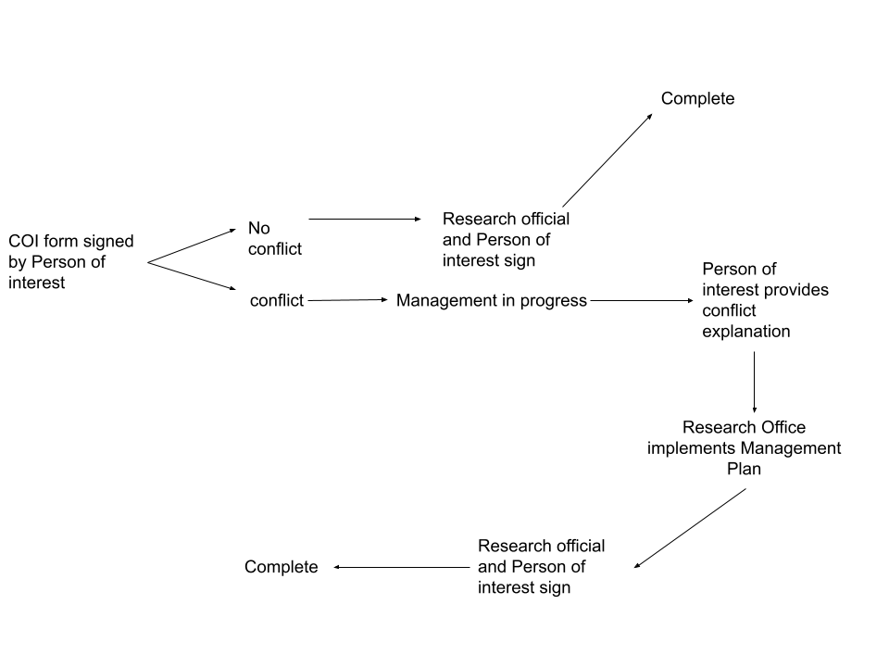
Figure 0.1Conflict Management Plan State Transition Diagram

Appendix C: Data Dictionary
[The data dictionary defines the composition of data structures and the meaning, data type, length, format, and allowed values for the data elements that make up those structures. In many cases, storing the data dictionary as a separate artifact, rather than embedding it in an SRS is beneficial. This also increases its reusability potential in other projects.

List data items alphabetically. Make each name a bookmark so each time the name occurs in this SRS it can be link to this entry via a hyperlink. Choose names with care. The expectation is that these names will persist in the design and implementation.]

Data Element | Description | Composition or Data type | Length | Values
Name of data item being defined | Textual description of the business meaning of the data element | For primitive data elements: data type (integer, floating point, alphabetic, date, etc.) and, as appropriate, format (e.g. date as MM/DD/YYYY).  For data structures show the components that comprise the structure. , | Maximum number of characters for primitives; blank for structures | List of allowed values, default, rules governing legal values, and any other description of the data values
… | … | .. | … | …

Appendix D: Report Specification
[This optional appendix contains descriptions of reports that the system needs to generate. Many applications involve generating reports from one or more databases, files or other information sources. Exploring the content and format of the reports needed is an important aspect of requirements develop. Describe the contents and layouts of each report, including changes being made in an existing version of the report. Indicate the conditions that will trigger generating the report (e.g., manual or automatic) the timing of report generation, and the disposition of the report, such as to whom it is sent or where it is stored.

Use the following template to document business rules.

Report ID:
Report Title:
Report Purpose:
Data Sources:
Frequency and Disposition:
Latency:
Visual Layout:
Header and Footer:
Report Body:
End-of-Report Indicator:
Interactivity:
Security Access Restrictions:

If appropriate, provide a mock-up or a sample of the report, or an illustration of a similar existing report, showing the desired layout. ]

Appendix E: Business Rules
Several business rules relevant to the COI System are identified in this appendix.

ID | Rule Definition | Type of Rule | Static or Dynamic | Source
BR-1 | Every conflict form (aside from the Chancellor’s and the Vice Chancellor of Research) must be signed by the Vice Chancellor of Research and the person filling out the form in order to be considered complete. | Fact | Static | COI Policy, 1998
BR-2 | Faculty must use their legal name as defined in Banner when signing forms. | Constraint | Dynamic | Where?
BR-3 | Employees working over one-half FTE a week, along with graduate students engaged in research, must complete a COI form. | Fact | Static | Montana Tech Faculty/Staff Handbook
BR-4 | Compliance of COI policy is required by all full-time and part-time Montana Tech employees, including students who receive compensation from Montana Tech and students or others who design, conduct, or report research, educational, or public service activities for Montana Tech | Fact | Static | Montana Tech Faculty/Staff Handbook
BR-5 | Research administrators cannot review and approve their own COI form | Fact | Static | COI Policy, 1998
Table 0.1Business Rules

Appendix F: Sample User Interface
[If a sample user interface exists, place it here. Make it clear that this user interface is only an example. If something is required in the user interface, state that earlier in this document.]

Appendix G: Issues
[This optional appendix is a dynamic list of the open requirements issues that remain to be resolved, including TBDs, pending.]

