Conflict of Interest System
MTM Program Product
Software Requirements Specification

Version 0.2
3/4/2022

Template Version 3.5

Standard Version Number: 3.5
Standard Version Date: March 10, 2018
Version History
Version | Date | Authors | Comment
0.1 | 2/18/2022 | Students of Req & Spec, Spring 2022 - Nathan Blakenship, Matthew Gallagher, Tucker Kane, Brandon Mitchell | Introduction: business objectives, vision, context, environment
0.2 | 3/4/2022 | Same as above | General factors: functions/features, users

Template Version History
Version | Date | Authors | Comment
3.0 | 7/21/2012 | Frank Ackerman | Initiating standards versions
3.1 | 8/2/2012 | Frank Ackerman | Some non-functional requirements definitions .Added Adaptability, Enhanceability, and Portability
3.2 | 1/17/2013 | Frank Ackerman | Added usability comment
3.3 | 3/6/2013 | Frank Ackerman | Added a bit more explanatory text and final section 8.
3.5 | 3/10/2018 | Celia Schahczenski | Changed format of dates, rearranged, renamed items, removed Illustrative Use Cases, increased some explanations, added appendices including data and report sections.

Montana Tech Software Engineering Students:
These Montana Tech Method software engineering standards encapsulate Dr. Ackerman’s decades of experience in the software industry, the IEEE software engineering standards, and many suggestions from various texts. They have gone through many revisions and additions over the last several years. They are part of your software engineering studies so that (1) you may have the experience of developing software to a standard (which you may find you need to do if you take a job that requires high reliability software), and so that (2) you will have the experience of developing high quality software. You are also invited to participate in the continuing evolution of these standards by studying them critically and making suggestions for their improvement and correction.

TABLE OF CONTENTS
1 Introduction 6
1.1 Software Purpose and Scope 6
1.2 Document Purpose and Contents 6
1.3 Definitions, Acronyms, Abbreviations and References 7
1.3.1 Definitions 7
1.3.2 Acronyms and Abbreviations 7
1.3.3 References 8
2 General Factors 8
2.1 Product Perspective 8
2.2 Environmental Conditions 9
2.3 User Characteristic 10
2.4 Dependencies 11
2.5 Assumptions 11
3 Use Cases 11
3.1 Actor 12
3.2 Use Cases 12
3.2.1 [Use Case Name] 12
3.2.2 [ Use Case Name 2] 13
4 Specific Requirements 14
4.1 Functional Requirements 14
4.2 Quality Attributes 14
4.2.1 Availability 14
4.2.2 Human Factors 14
4.2.3 Usability 14
4.2.4 Performance 15
4.2.5 Security 15
4.2.6 Reliability 15
4.2.7 Maintainability 15
4.2.8 Enhanceability/Extendibility 15
4.2.9 Portability 15
4.2.10 V&V Activities 15
4.2.11 Adaptability 15
4.3 Non-Functional Requirements Which Are Not Quality Attributes 15
4.3.1 External Interface Requirements 15
4.3.2 Development Environment 15
4.3.3 Delivery Environment 15
4.3.4 Design Constraints 16
4.3.5 Database 16
4.3.6 Deliverable Items, Dates and Conditions 16
4.3.7 Cost 16
4.3.8 Standards 16
5 Future Enhancements 16
Appendices 18
Appendix B: Analysis Models 18
Appendix C: Data Dictionary 18
Appendix D: Report Specification 19
Appendix E: Business Rules 20
Appendix F: Sample User Interface 21
Appendix G: Issues 21

Table of Figures
Figure 2.1 COI System Ecosystem Map 9
Figure 2.2COI System Context Diagram 10
Figure 0.1Conflict Management Plan State Transition Diagram 18

Table of Tables

Table 1.1 Definitions 7
Table 1.2 Acronyms 7
Table 2.1 User Classes 11
Table 0.1Business Rules 21

Introduction
This section provides an overview of the Conflict of Interest (COI) System, the purpose of this document, and definitions, acronyms and references related to conflicts of interest.

Software Purpose and Scope
The purpose of the Conflict of Interest System (COI) System is to help the Research Office handle conflicts of interest for Montana Technological University (subsequently known as Montana Tech). For Montana Tech affiliated members who fall under the COI policy, the COI System is an interactive user interface, storage, and reporting system that will reduce user and staff input to less than 40 hours per year, guarantee a 95% or better completion rate for all faculty and staff, and generate annual reports. Unlike the previous systems used by the research office, this system accurately collects statistics, chooses correct recipients, saves time, educates users on the COI policy, and generates reports.

Document Purpose and Contents
The purpose of this Software Requirements Specification (SRS) is to give readers an understanding of Montana Tech’s goals and needs for a COI System. It provides a guide for future developers on the desired features, functionality and behaviors of the COI System. This document can be used to design tests to ensure an implementation behaves as intended.

Customers sometimes find sample interfaces easier to understand than documents such as this SRS. Sample user interfaces demonstrate one way that the software could appear. This document goes further to tell precisely what functionality is needed.

This document does not attempt to tell how this software should be implemented except in those cases where the customers want the application to be developed in a particular way. Deciding exactly what a system should do, before deciding how it will do it, reduces development time considerably.

This SRS was developed by students in Software Requirement and Specification (ESOF 328), in the Spring 2022 at Montana Tech. It has been developed in part by faculty members, administrative personal and students. Thanks goes to Angela Lueking, Jill Yoder, Muhammad Abdul Basit UR Rahim, Trevor Osborne, and Ryan Hessler. The main audience of this document are the clients as well as the developers that will use this document to implement the system.

Definitions, Acronyms, Abbreviations and References
This section defines technical terms used in this document, as well as the expansions of acronyms and abbreviations, and important references.

Definitions
This subsection contains definitions of terms used in this document.

Conflict of interest and financial disclosure | Occurs “…when there is a potential divergence between the employee’s private interests and professional obligations to Montana Tech, such that an independent observer might reasonably question whether the employee’s professional actions or decisions could be influenced by considerations of personal gain (financial or otherwise).” From the Conflict of Interest and Financial Disclosure policy
Status of COI form | COI forms can be: not started, in progress, pending or completed (each of these need to be defined)
Status of management plan | This could be combined with the status of COI forms, it could be a subset, or could stand on its own.
Bins | Categories of COI conflicts The categories need to be defined.
Table 1.1 Definitions

Acronyms and Abbreviations
Acronyms and abbreviations found in this document are included in this subsection.

COI | Conflict of Interest
FTE | Full-Time Equivalent, a designation of how the workload of a faculty member or student. For faculty members, 1.0 FTE = 40 hours. For students during the academic year, 1.0 FTE = 20 hours.
PoI | Person of Interest, anyone who will be using the COI System to sign a conflict of interest form
SRS | Software Requirements Specification, term used for this document
SSO | Single Sign-On, the secure login system commonly used for Montana Tech applications
Table 1.2 Acronyms

References
References relevant to the Conflict of Interest System are given in this subsection.

Banner
https://www.ellucian.com/solutions/ellucian-banner-human-resources

Conflict of Interest and Financial Disclosure Policy (1998), Montana Technological University,
https://www.mtech.edu/research/files/conflict-interest-financial-disclosure.pdf

Conflict of Interest Disclosure Statement and Certification Portal, Montana Technological University, https://mtlbsso.mtech.edu/idp/profile/cas/login?execution=e1s1

Montana Technological University Faculty/Staff Handbook
https://www.mtech.edu/facultystaff/fac-staff-handbook-acc.pdf

General Factors
A high-level overview of what the COI System will do, its running environment, who will use it, its dependencies, and assumptions made about it are included in this section.

Product Perspective
This system is meant to serve as a replacement to the current COI process. In addition, this project will be dependent on the Banner and Single Sign-On systems of Montana Tech.

Product Functions
The COI System will:
- Educate: The system will educate users on what is a conflict of interest, the importance of disclosing conflicts, and the consequences of not properly disclosing information on the form.
- Create: The system will enable People of Interest to complete, sign, and submit COI forms online, approving the document with their digital signature.
- Manage forms: The system will aid Research Office personnel to easily see the status of all COI forms.
- Aid in conflict management: The system will aid Research Office personnel to easily see who has potential conflicts, the status of those conflicts, and to record how those conflicts will be managed.
- Report: The system will generate yearly reports on the data gathered from the signed COI forms to submit to Montana Tech’s Board of Regents.

Environmental Conditions
The Montana Board of Regents requires the submission of annual conflict of interest reports from each of its universities, including Montana Tech. Banner holds the information necessary to uniquely identify employees and graduate students engaged in research. Microsoft Outlook is the most likely tool to be used to distribute COI forms as each employee and student has their own unique email address. COI System authorization will be Montana Tech’s Single Sign-On (SSO) System. Figure 2.1 COI System Ecosystem Map shows the interactions of the COI System. Figure 2.2COI System Context Diagram shows the context in which the COI System will operate.

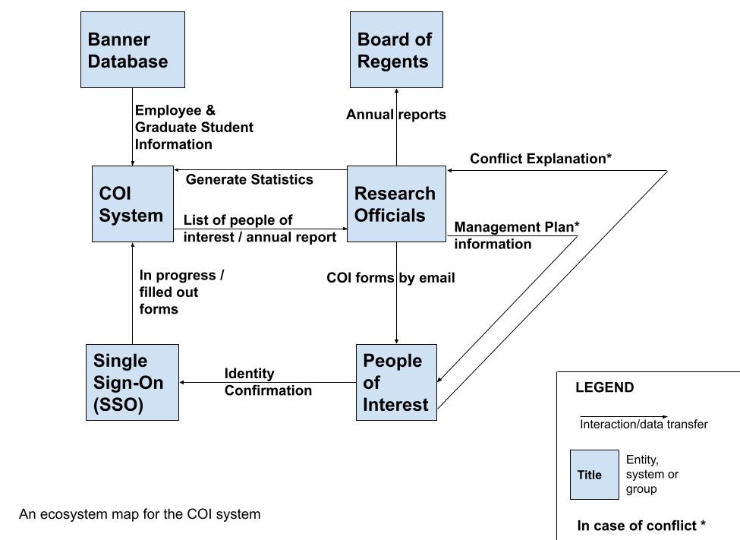
Figure 2.1 COI System Ecosystem Map

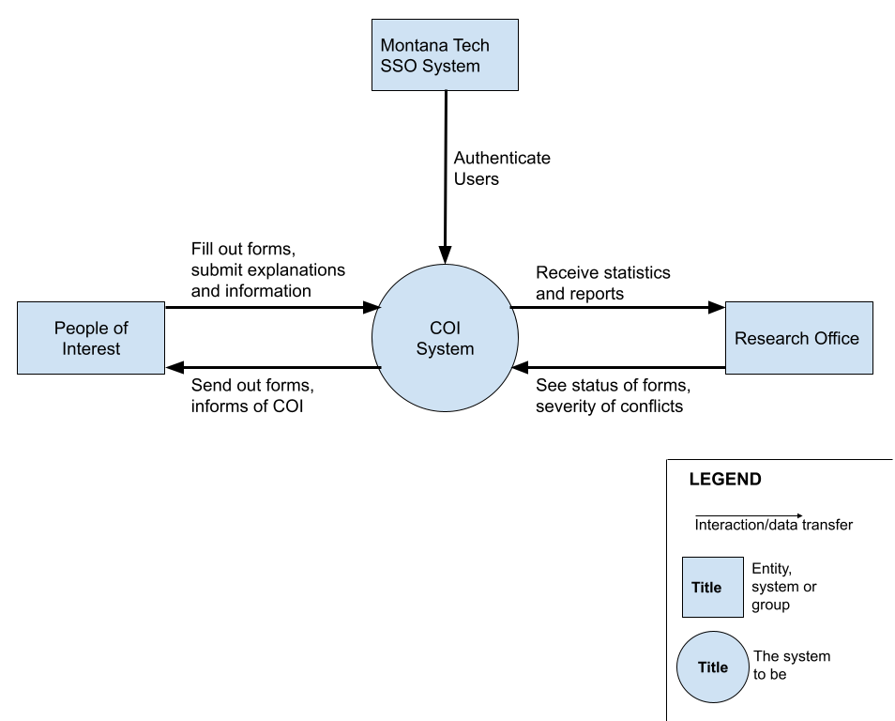
Figure 2.2COI System Context Diagram

User Characteristic
There are three primary user classes for the COI system. These users are separated by level of privilege and responsibilities. Table 2.1 User Classes
Table 2.1 User Classes below lists the users and what they are allowed to do within the system.

Although the system will generate reports for the Board of Regents to comply with state laws, the Board of Regents will never interact with the system directly or indirectly. They will only receive the report the system generates. As such, they are not represented in the table.

User Class | Description
Auditors | A few key individuals in the Research Office with the privilege of signing off on forms. The ability to sign off on forms to complete them is their key distinction from Admins.
Admins | Individuals in the Research Office that have the ability to review other’s forms as well as their status and the severity of their conflict (if one exists). They will also be able to generate yearly reports to comply with state law.
People of Interest | General users of the system. They consist of anyone who is required to complete a COI form. Their use of the system will be to complete and submit the form as well as providing an explanation for any conflicts. (Admins will need to sign COI forms, so they will engage with the COI System as ‘People of Interest’ at times.)
Table 2.1 User Classes

Dependencies
The COI System is dependent on the Single Sign-On System, of Montana Tech.

The system will be dependent on Banner for the legal names of employees and graduate students engaged in research.

Assumptions
Some assumptions for this system are:
- Auditors consists of the Vice Chancellor of Research and anyone who is allowed to sign on their behalf.
- People of Interest are employees with greater than one-half FTE or graduate students engaged in research.
- All actual conflicts of interest will be managed by the Research Office. The COI System will not manage any conflicts, only sort them and generate some statistics.
- This system will be available on any computer with a modern web browser and Internet connectivity.
- The Chancellor and Vice Chancellor of Research are unable to sign off on their own COI form. As such, someone at the University of Montana in Missoula needs to sign off, and we are assuming they will not be interacting with our system.

Use Cases
[Use cases describe possible interactions between an actor and a system that results in an outcome that provides value to the actor. Develop these use cases with the client. This section may begin with a use case diagram, an analysis model that identifies the actors who can interact with a system, along with the various use cases with which each actor might be involved.

If no use cases exist for this product, this section should read “Use Cases were not developed for this specification”.]

Actor
[This subsection lists the various actors that will interact with the proposed system, along with the interactions that these actors may perform. An actor is a person, or other entity external to the software system, who may interacts with the proposed system to accomplish tasks. Actors may represent roles, identified from the customer community that will use the product.

The following is a template for documenting user classes and the associated use cases.]

Primary Actor | Use Cases
Actor 1 | - Use case 1  - Use case 2  …
Actor 2 | - Use case 1  - Use case 2  …
… | …

Use Cases
[This subsection contains use cases of the proposed system. Use cases can be “casual” or “fully dressed”. The template given is for a fully dressed use case. Omit portions of this template for casual use cases.

[Use Case Name]
Created By: | Name 1 | Last Updated By: | Name 2
Date Created: | Month dd, yyyy | Date Last Updated: | Month dd, yyyy
Actors: | User class name
Description: | Description of use case
Preconditions: | - Precondition 1 or “none”  - …
Postconditions: | - Postcondition 1 or “none”  - …
Normal Flow: | 1.0 Description phrase  - Step 1.  - Step 2.  - …
Alternative Flows: | 1.1 Description phrase for alternative flow (branch after step n)  - Step 1.  - Step 2.  …  n. Return to Step m.  1.2 Description phrase for 2nd alternative flow (branch after step l)  - …
Exceptions: | 1.0.E.1 Description phrase for exception (at step k)  - Step 1.  - Step 2.  …  1.0.E.2 Description phrase for 2nd exception (at step j)  1. …
Includes/Extends: | Name of included use cases, name of the use cases that this use case extends, or “none”
Priority: | Low, medium or critical
Frequency of Use: | How often it is expected that this use case will be performed.
Business Rules: | Business rules can be listed, or another document can be referenced, or “none”
Special Requirements: | - Special requirements 1 concerning this use case.  - …  or “none”
Assumptions: | - Assumption 1 concerning this use case.  - …  or “none”
Notes and Issues: | - Note 1 concerning this use case.  - …  or “none”  This can serve as a placeholder for extraneous information.

[ Use Case Name 2]
…

Specific Requirements
The following section contains all of the requirements for the COI System. The details
within this section are defined as individual, specific requirements. Each requirement is
tagged with a priority to indicate its importance. In order from least importance to most
importance, the possible priority levels are: low, medium, high, and critical. Each
requirement is clearly identified for tracking.

Functional Requirements
[This subsection should specify how the software product will react to every possible input situation. It describes all the actions that must take place in the software in response to every input. Pertinent changes in the environment are considered to be inputs.

Care must be taken to avoid dropping into design details. In the user cannot directly experience the effect of a requirement it probably crossed the line into design.

Functional requirements should be logically grouped. Each group should have a short, unique (within the SRS) abbreviation and a number. The word processing section number will probably change as the SRS is developed.

For each identified requirement an optional rationale for that requirement may be given.

Most modern software should provide at least a modicum of user help. For very complex applications in situ help may be supplemented by a user’s manual (or manual page) but for many simple applications comprehensive in situ help is sufficient.]

Quality Attributes
[This subsection specifies criteria used to judge the operation of a system, rather than specific behaviors of the system. Specify the specific behavior of the system in the functional requirements.]

Availability

Human Factors
[Not everyone has the same inherent mental and physical capabilities vis-à-vis a given computer application. For example if sound is part of the application, will other clues be given that will enable a hard of hearing user to use the proposed application as well as person with normal hearing; similarly for color blindness. Define these factors, if necessary, with validation criteria.]

Usability

Performance

Security

Reliability
[Reliability is specified as mean-time-to failure of an operational item. An operational profile must be specified.]

Maintainability

Enhanceability/Extendibility
[If the future it might be necessary to change the Functional requirements in specified ways, what is the maximum estimated effort required to make such changes and what is the rationale for this estimate?]

Portability
[If in the future it might be necessary to change the above Development or Delivery Environments (DV or DL) to other specified environments, what is the maximum estimated effort required to implement such changes and what is the rationale for this estimate]

V&V Activities

Adaptability
[If it is specified that in the future it might be necessary to change any of the above Non-Functional requirements, what is the maximum estimated effort required to implement such changes and what is the rationale for this estimate.]

Non-Functional Requirements Which Are Not Quality Attributes
[This subsection specifies non-functional criteria such as platform, deployment, interface, design and document requirements. If there is not a document describing project requirements, those requirements (cost, schedule, etc.) can be placed here.]

External Interface Requirements

Hardware

Software

Communications

Development Environment

Delivery Environment

Site
[This subsection should specify any requirements for installation or operation of the software that might change the pre-existing configuration of the user site.]

Operations
[This subsection should specify normal and special operations required by the user to include:
- Various modes of operation within the user organization
- Periods of interactive operations and unattended operations
- Data processing support functions
- Backup and recovery operation.]

Design Constraints
[Sometimes a client will require certain design constraints, for example the use of a certain system configuration or the use of particular algorithm. Such constraints are described in this subsection.]

Database
[This optional subsection specifies requirements for any database to be developed as part of the product. The information in this section may include:
- Types of information to be stored
- Table attributes (queried, supporting, updated)
- Frequency of access
- Accessing capabilities and requirements
- Data elements and file descriptors
- Retention requirements for data.]

Take care to avoid design details. Unless so requested by the client, this section should only contain as much information about saved data as is necessary to fully document any of the requirements given above.]

Deliverable Items, Dates and Conditions

Cost

Standards

Future Enhancements
[This section should describe any future enhancements that are contemplated at the time this SRS completed. If there is no known possibility that this product will be enhanced in the future this section should read : It is not expected that there will be any future enhancements to this product.]

Appendices
[In some cases, it is helpful to move items out of the main portion of the Software Requirements and Specification Document. These items can appear here. Alternatively, move these items into the main part of the document.]

Appendix B: Analysis Models
Models help to clarify the requirements. The following model shows the states of a conflict management plan and the events that take the plan from one state to another.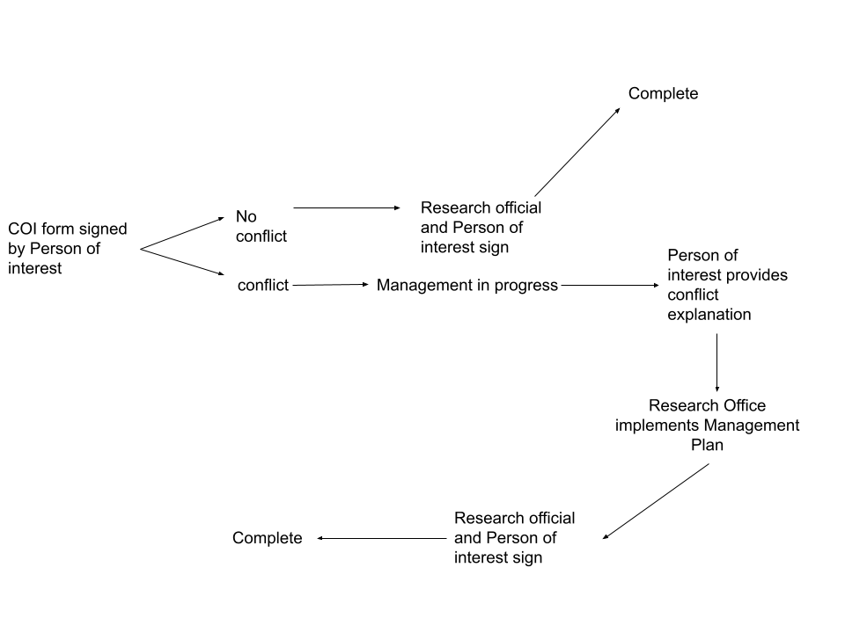
Figure 0.1Conflict Management Plan State Transition Diagram

Appendix C: Data Dictionary
[The data dictionary defines the composition of data structures and the meaning, data type, length, format, and allowed values for the data elements that make up those structures. In many cases, storing the data dictionary as a separate artifact, rather than embedding it in an SRS is beneficial. This also increases its reusability potential in other projects.

List data items alphabetically. Make each name a bookmark so each time the name occurs in this SRS it can be link to this entry via a hyperlink. Choose names with care. The expectation is that these names will persist in the design and implementation.]

Data Element | Description | Composition or Data type | Length | Values
Name of data item being defined | Textual description of the business meaning of the data element | For primitive data elements: data type (integer, floating point, alphabetic, date, etc.) and, as appropriate, format (e.g. date as MM/DD/YYYY).  For data structures show the components that comprise the structure. , | Maximum number of characters for primitives; blank for structures | List of allowed values, default, rules governing legal values, and any other description of the data values
… | … | .. | … | …

Appendix D: Report Specification
[This optional appendix contains descriptions of reports that the system needs to generate. Many applications involve generating reports from one or more databases, files or other information sources. Exploring the content and format of the reports needed is an important aspect of requirements develop. Describe the contents and layouts of each report, including changes being made in an existing version of the report. Indicate the conditions that will trigger generating the report (e.g., manual or automatic) the timing of report generation, and the disposition of the report, such as to whom it is sent or where it is stored.

Use the following template to document business rules.

Report ID:
Report Title:
Report Purpose:
Data Sources:
Frequency and Disposition:
Latency:
Visual Layout:
Header and Footer:
Report Body:
End-of-Report Indicator:
Interactivity:
Security Access Restrictions:

If appropriate, provide a mock-up or a sample of the report, or an illustration of a similar existing report, showing the desired layout. ]

Appendix E: Business Rules
Several business rules relevant to the COI System are identified in this appendix.

ID | Rule Definition | Type of Rule | Static or Dynamic | Source
BR-1 | Every conflict form (aside from the Chancellor’s and the Vice Chancellor of Research) must be signed by the Vice Chancellor of Research and the person filling out the form in order to be considered complete. | Fact | Static | COI Policy, 1998
BR-2 | Faculty must use their legal name as defined in Banner when signing forms. | Constraint | Dynamic | Where?
BR-3 | Employees working over one-half FTE a week, along with graduate students engaged in research, must complete a COI form. | Fact | Static | Montana Tech Faculty/Staff Handbook
BR-4 | Compliance of COI policy is required by all full-time and part-time Montana Tech employees, including students who receive compensation from Montana Tech and students or others who design, conduct, or report research, educational, or public service activities for Montana Tech | Fact | Static | Montana Tech Faculty/Staff Handbook
BR-5 | Research administrators cannot review and approve their own COI form | Fact | Static | COI Policy, 1998
Table 0.1Business Rules

Appendix F: Sample User Interface
[If a sample user interface exists, place it here. Make it clear that this user interface is only an example. If something is required in the user interface, state that earlier in this document.]

Appendix G: Issues
[This optional appendix is a dynamic list of the open requirements issues that remain to be resolved, including TBDs, pending.]

