Homework 4: Games

Name ___________________________________

Question 1: Minimax
0.0/4.0 points
Consider the zero-sum game tree shown below. Triangles that point up, such as at the top node (root), represent choices for the maximizing player; triangles that point down represent choices for the minimizing player. Outcome values for the maximizing player are listed for each leaf node, represented by the values in squares at the bottom of the tree. Assuming both players act optimally, carry out the minimax search algorithm. Enter the values for the letter nodes in the boxes below the tree.
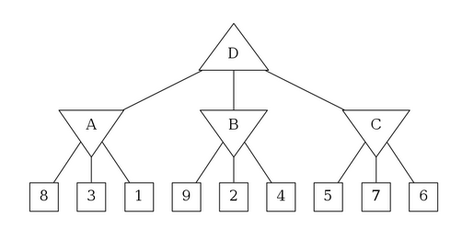

A | B | C | D

Question 2: Expectiminimax
0.0/7.0 points
Consider the game tree shown below. As in the previous problem, triangles that point up, such as the top node (root), represent choices for the maximizing player; triangles that point down represent choices for the minimizing player. The circular nodes represent chance nodes in which each of the possible actions may be taken with equal probability. The square nodes at the bottom represent leaf nodes. Assuming both players act optimally, carry out the expectiminimax search algorithm. Enter the values for the letter nodes in the boxes below the tree.
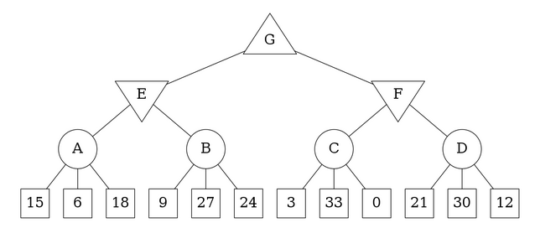

A | B | C | D | E | F | G

Question 3: Unknown Leaf Value
0.0/8.0 points
Consider the following game tree, where one of the leaves has an unknown payoff, x. Player 1 moves first, and attempts to maximize the value of the game.
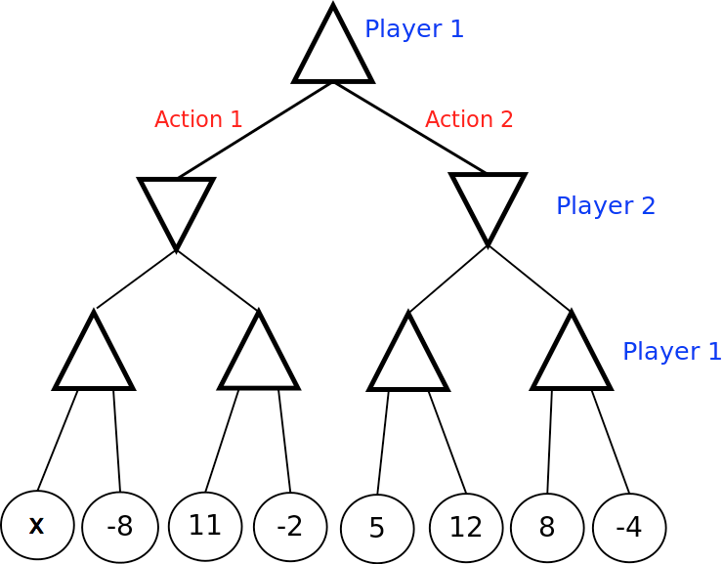
Each of the next 3 questions asks you to write a constraint on x specifying the set of values it can take. In your constraints, you can use the letter x, integers, and the symbols > and <. If x has no possible values, write 'None'. If x can take on all values, write 'All'. As an example, if you think x can take on all values larger than 16, you should enter x > 16.
Assume Player 2 is a minimizing agent (and Player 1 knows this). For what values of x is Player 1 guaranteed to choose Action 1?

Assume Player 2 chooses actions at random with each action having equal probability (and Player 1 knows this). For what values of x is Player 1 guaranteed to choose Action 1?

Denote the minimax value of the tree as the value of the root when Player 1 is the maximizer and Player 2 is the minimizer. Denote the expectimax value of the tree as the value of the root when Player 1 is the maximizer and Player 2 chooses actions at random (with equal probability). For what values of x is the minimax value of the tree worth more than the expectimax value of the tree?

Is it possible to have a game, where the minimax value is strictly larger than the expectimax value?
Yes
No

Question 4: Alpha-Beta Pruning
0.0/13.0 points
Consider the game tree shown below. Triangles that point up, such as at the top node (root), represent choices for the maximizing player; triangles that point down represent choices for the minimizing player. Assuming both players act optimally, use alpha-beta pruning to find the value of the root node. The search goes from left to right; when choosing which child to visit first, choose the left-most unvisited child. In the first set of boxes below, enter the values of the labeled nodes. Then, in the second set of boxes, enter a 'x' for the leaf nodes that don't get visited due to pruning. For leaf nodes that do get visited, leave the corresponding entry blank.
Hint: Note that the value of a node where pruning occurs is not necessarily the maximum or minimum (depending on which node) of its children. When you prune on conditions V > β or
V < α, assume that the value of the node is V.
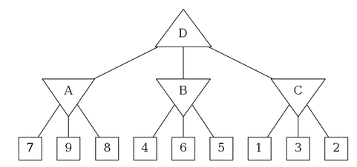
.

A |  |  | B |  |  | C |  |  | D
7 | 9 | 8 |  | 4 | 6 |  | 5 | 1 |  | 3 | 2

Question 5.1: Non-Zero-Sum Games
0.0/8.0 points
The standard minimax algorithm calculates worst-case values in a zero-sum two player game, i.e. a game for which in all terminal states s, the utilities for players A (MAX) and B (MIN) obey U_{A}(s) + U_{B}(s) = 0. In this zero-sum setting, we know that U_{A}(s) = U_{B}(s), so we can think of player B as simply minimizing U_{A}. In this problem, you will consider the non-zero-sum generalization, in which the sum of the two players' utilities are not necessarily zero. The leaf utilities are now written as pairs (U_{A}, U_{B}). In this generalized setting, A seeks to maximize U_{A}, the first component, while B seeks to maximize U_{B}, the second component.
Consider the non-zero-sum game tree below. Note that left-pointing triangles (such as the root of the tree) correspond to player A, who maximizes the first component of the utility pair, whereas right-pointing triangles (nodes on the second layer) correspond to player B, who maximizes the second component of the utility pair. Propagate the terminal utility pairs up the tree using the appropriate generalization of the minimax algorithm on this game tree. In case of ties, choose the leftmost child. Select the correct values for the letter nodes below the tree.
Your answer should be in the format (X, Y), where X is the value of Player A and Y is the value of Player B at a node.
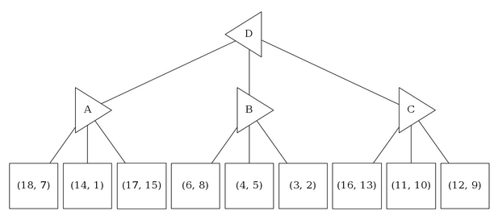

A | B | C | D

Question 5.2: Properties of Non-Zero-Sum Games
0.0/6.0 points
In this problem, you will again consider the non-zero-sum generalization, in which the sum of the two players' utilities are not necessarily zero. The leaf utilities are now written as pairs
(U_{A}, U_{B}). In this generalized setting, A seeks to maximize U_{A}, the first component, while B seeks to maximize U_{B}, the second component.
Assume that your generalization of the minimax algorithm calculates a value (U_{A}, U_{B}) for the root of the tree. Assume no utility value for A or for B appears more than once in the terminal nodes (this means there will be no need for tie-breaking). Which of the following statements are true?
Assuming A and B both play optimally, player A's outcome is guaranteed to be exactly U_{A}.
Assuming A and B both play optimally, player B's outcome is guaranteed to be exactly U_{B}.
Assuming B plays sub-optimally (but A plays optimally), A's outcome is guaranteed to be at least U_{A}.

Question 6: Possible Pruning
0.0/5.0 points
Assume we run α-β pruning, expanding successors from left to right, on a game with tree as shown in Figure (a) below.
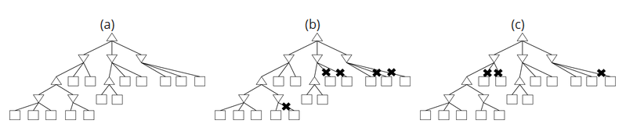

There exists an assignment of utilities to the terminal nodes such that no pruning will be achieved (shown in Figure (a)).
There exists an assignment of utilities to the terminal nodes such that the pruning shown in Figure (b) will be achieved.
There exists an assignment of utilities to the terminal nodes such that the pruning shown in Figure (c) will be achieved.
None of the above.

problem
0.0/5.0 points
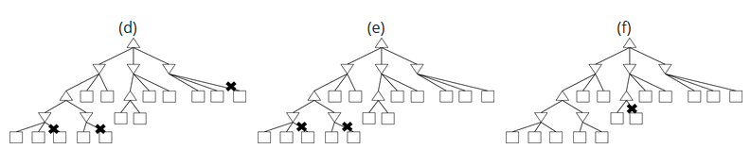

There exists an assignment of utilities to the terminal nodes such that the pruning shown in Figure (d) will be achieved.
There exists an assignment of utilities to the terminal nodes such that the pruning shown in Figure (e) will be achieved.
There exists an assignment of utilities to the terminal nodes such that the pruning shown in Figure (f) will be achieved.
None of the above.

Question 7: Suboptimal Strategies
0.0/3.0 points
Player MAX and player MIN are playing a zero-sum game with a finite number of possible moves. MAX calculates the minimax value of the root to be M. You may assume that at every turn, each player has at least 2 possible actions. You may also assume that a different sequence of moves will always lead to a different score (i.e., no two terminal nodes have the same score). Which of the following statements are true?
Assume MIN is playing sub-optimally at every turn, but MAX does not know this. The outcome of the game could be larger than M (i.e. better for MAX).
Assume MIN is playing sub-optimally at every turn. If MAX plays according to the minimax strategy, the outcome of the game could be less than M.

problem
0.0/3.0 points
For this question, assume that MIN is playing randomly (with a uniform distribution) at every turn, and MAX knows this.
There exists a policy for MAX such that MAX can guarantee a better outcome than M.
There exists a policy for MAX such that MAX's expected outcome is better than M.
To maximize his or her expected outcome, MAX should play according to the minimax strategy (i.e. the strategy that assumes MIN is playing optimally).

problem
0.0/3.0 points
Assume MIN is playing sub-optimally at every turn. MAX following the minimax policy will guarantee a better outcome than M.
Assume MIN is playing sub-optimally at every turn, and MAX knows exactly how MIN will play. There exists a policy for MAX to guarantee a better outcome than M.

Question 8: Shallow Search
0.0/8.0 points
In this question, we will investigate shallow search, also known as depth-limited search. Depth-limited search is not guaranteed to find the optimal solution to the original problem. The point of this question is to explore some of the (potentially undesirable) behavior of depth-limited search, and to illustrate that the quality of the evaluation function can play a big role in how well depth-limited search performs.
Consider the following Pacman configuration, in the board below. At each time step, Pacman can move either West (left) or East (right) and is using limited-depth minimax search (where the minimizing agent does not really do anything) to choose his next move. Pacman is 3 East moves away from the food, and chooses from the following state evaluation functions:
- F1(state) = -Number of food pellets left
- F2(state) = -Number of food pellets left + 0.5/(distance to closest food pellet + 1); distance to closest food pellet is taken as 0 when no food remains.
The search depth referred to in this question corresponds to the depth in a search tree that only considers the maximizer's actions. For example, if the search considers sequences of up to 2 actions by the maximizer, it'd have a search depth of 2.
In the questions below, optimality means that the action is an optimal first action according to the search tree with the specified depth and the specified evaluation function. In each of these questions, there are 5 different search trees under consideration: one of depth 1, one of depth 2, ..., and one of depth 5.
Note that there can be more than one optimal action for a given search tree (this can happen whenever there are ties). Also, note that a search does not finish when the dots are eaten.
Using F1 as the state evaluation function, for what search depths will East be an optimal action?
1
2
3
4
5
Using F1 as the state evaluation function, for what search depths will West be an optimal action?
1
2
3
4
5
Using F2 as the state evaluation function, for what search depths will East be an optimal action?
1
2
3
4
5
Using F2 as the state evaluation function, for what search depths will West be an optimal action?
1
2
3
4
5

Question 9: Rationality of Utilities
0.0/3.0 points

Part 1
Consider a lottery L = [0.2, A; 0.3, B; 0.4,C; 0.1, D], where the utility values of each of the outcomes are U(A) = 1, U(B) = 3, U(C) = 5, U(D) = 2. What is the utility of this lottery, U(L)?

Part 2
0.0/3.0 points
Consider a lottery L1 = [0.5, A; 0.5, L2], where U(A) = 4, and L2 = [0.5, X; 0.5, Y] is a lottery, and U(X) = 4, U(Y) = 8. What is the utility of the first lottery, U(L1)?

Part 3
0.0/3.0 points
Assume A $≻$ B, B $≻$ L, where L = [0.5, C; 0.5, D], and D $≻$ A. Assuming rational preferences, which of the following statements are guaranteed to be true?
A $≻$ L
A $≻$ C
A $≻$ D
B $≻$ C
B $≻$ D

Question 10: Certainty Equivalent Values
0.0/4.0 points
Consider the utility function shown below.
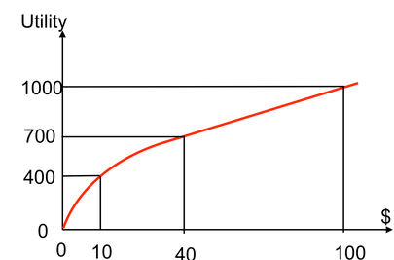
Under the above utility function, what is the certainty equivalent monetary value in dollars ($) of the lottery [0.6, $0; 0.4, $100]?
I.e., what is X such that U($X) = U([0.6, $0; 0.4, $100])?
Hint: Keep in mind that U([p, A; 1-p, B]) is not equal to U(pA + (1-p)B).

Question 11: Preferences and Utilities
0.0/2.0 points
Our Pacman board now has food pellets of 3 different sizes - pellet P₁ of radius 1, P₂ of radius 2 and P₃ of radius 3. In different moods, Pacman has different preferences among these pellets. In each of the following questions, you are given Pacman's preference for the different pellets. From among the options pick the utility functions that are consistent with Pacman's preferences, where each utility function U(r) is given as a function of the pellet radius r, and is defined over non-negative values of r.
P₁ ~ P₂ ~ P₃
U(r) = 0
U(r) = 3
U(r) = r
U(r) = 2r + 4
U(r) = -r
U(r) = r²
U(r) = -r²
U(r) = √r
U(r) = -√r
Irrational preferences!

problem
0.0/2.0 points
P₁ $≺$ P₂ $≺$ P₃
U(r) = 0
U(r) = 3
U(r) = r
U(r) = 2r + 4
U(r) = -r
U(r) = r²
U(r) = -r²
U(r) = √r
U(r) = -√r
Irrational preferences!

problem
0.0/2.0 points
P₁ $≻$ P₂ $≻$ P₃
U(r) = 0
U(r) = 3
U(r) = r
U(r) = 2r + 4
U(r) = -r
U(r) = r²
U(r) = -r²
U(r) = √r
U(r) = -√r
Irrational preferences!

problem
0.0/2.0 points
(P₁ $≺$ P₂ $≺$ P₃₎ and (P₂ $≺$ (50-50 lottery among P₁ and P₃))
U(r) = 0
U(r) = 3
U(r) = r
U(r) = 2r + 4
U(r) = -r
U(r) = r²
U(r) = -r²
U(r) = √r
U(r) = -√r
Irrational preferences!

problem
0.0/2.0 points
(P₁ $≻$ P₂ $≻$ P₃₎ and (P₂ $≻$ (50-50 lottery among P₁ and P₃))
U(r) = 0
U(r) = 3
U(r) = r
U(r) = 2r + 4
U(r) = -r
U(r) = r²
U(r) = -r²
U(r) = √r
U(r) = -√r
Irrational preferences!

problem
0.0/2.0 points
(P₁ $≺$ P₂) and (P₂ $≺$ P₃₎ and ((50-50 lottery among P₂ and P₃) $≺$ (50-50 lottery among P₁ and P₂))
U(r) = 0
U(r) = 3
U(r) = r
U(r) = 2r + 4
U(r) = -r
U(r) = r²
U(r) = -r²
U(r) = √r
U(r) = -√r
Irrational preferences!

problem
0.0/2.0 points
Which of the following would be a utility function for a risk-seeking preference? That is, for which utility(s) would Pacman prefer entering a lottery for a random food pellet, with expected size s, over receiving a pellet of size s?
U(r) = 0
U(r) = 3
U(r) = r
U(r) = 2r + 4
U(r) = -r
U(r) = r²
U(r) = -r²
U(r) = √r
U(r) = -√r

