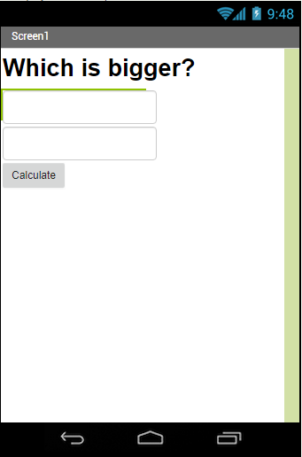

Label, Bold Font, Font Size 30
Two text boxes

Button that says Calculate

Label set to not visible until the Calculate button is clicked.
Font size 42
When Calculate is clicked. Set Label to visible and display the bigger number. If they are the same display the number.
