Hit the windows key, type ais and select aiStarter

Using Google Chrome, go to the following URL: http://ai2.appinventor.mit.edu

Start your project by following tutorial instructions given out.

Connect to the emulator.
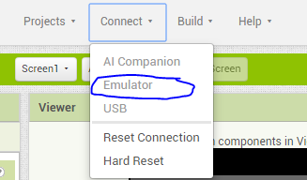

Finish tutorial instructions.

